FSK 116 - Summary

Chapter 1 - Introduction

General Information
- Fundamental physical quantities – methods of measurement that cannot be simplified
  - Example – time (s), distance (m) and mass (g)
- Derived quantities – quantities that can be simplified into base units
  - Example – density (mass per unit volume – kg/m³)
- Matter is made up of tiny atoms – previously thought to be the smallest particle
  - Can be broken into neutrons, protons and electrons
  - These can then be broken down into quarks
    - Up, down, strange, charmed, top and bottom

Dimensional analysis
- Often to develop equations it is necessary to if the solution and equation exist in the same dimensions, for example x=1/2at² and not just x=1/2at
- To determine the accuracy of the exponents in unknown equations:
  - Begin with the equation: $x∝ a^{m}t^{n}$, where the m and n represent random exponential variables
  - Break down your values into their core dimensions i.e. $a=x/t^{2}$
  - Then use exponential laws to determine the values of m and n
- Example: determine an equation for the a of an particle moving with uniform speed v in a circle of radius r
$$a=kr^{n}v^{m}$$
$$\frac{x}{t^{2}}=x^{n}×{\frac{x}{t}}^{m}$$
$$\frac{x}{t^{2}}={\frac{x}{t^{m}}}^{m+n}$$
$$∴m=2 and n= -1$$
$$a=k\frac{v^{2}}{r}$$

Estimates
- Often in physics, numbers are very small or very large, thus is often applicable to estimate their values to a nearest power of ten if accuracy is not required
- Numbers can be rounded off to the nearest power of ten
  - Rounded up if they are greater than 3.162
  - Rounded down if they are less than 3.162
- These methods are often useful to quickly check calculation values

Significant figures
- As previously stated, numbers in physics can be very big or very small, thus they need to be rounded off
- A significant figure is the digits in the number that hold value (not zeros indicating decimals)
  - E.g. In 0.00789, the 789 are significant values
  - E.g. In 3.002, all of the digits are significant
- For multiplication - Final answers should be rounded to the number of significant figures present in the given data piece with the smallest number of significant figures
  - E.g. 3,02 x 2,567 = 7.75 and not 7.752
- For addition or subtraction – answers should be rounded to the number of decimals present in the given data piece with the fewest number of decimals
  - E.g. 3,002+1003.52 = 1006.52 and not 1007 or 1006.522

Chapter 2 – Motion in 1 dimension

Position, velocity and speed
- Position (x) - with respect to an origin (chosen by an observer)
  - Can be positive or negative according to displacement direction
  - X-t graphs
    - Curving to vertical – speeding up
    - Curving to horizontal – slowing down
    - Horizontal – stationary
    - Slope – constant velocity
    - Line coming back towards axis – traveling in opposite direction
    - Negative displacement – object has gone past starting point
    - V- gradient
- Average speed – scalar
  - $V_{avg}=\frac{d}{∆t}$
- Velocity – vector
  - $V_{x}=\frac{∆x}{∆t}$ – average velocity
  - Instantaneous velocity - $V_{x}=\frac{dx}{dt}$
  - V-t graph
    - + and - is direction
    - Going away from zero – getting faster
    - Going towards zero – getting slower
    - At zero – stationary
    - Parallel to axis – constant velocity
    - Acceleration – gradient of a v-t graph
    - Displacement – area under a V-t graph
  - If v is constant then the equation $x=x_{i}+v_{x}t$ can be used

Acceleration
- Rate of change in a particles velocity
- $a=\frac{∆v}{∆t}$ – average acceleration
- $a=\frac{dv}{dt}=\frac{d^{2}x}{dt^{2}}$
  - Second derivative of the x-t graph gives acceleration
- A-t graphs
  - Area under graph (integration) – velocity
  - If a is positive
    - Accelerating forwards or
    - Decelerating backwards
  - If a is negative
    - Accelerating backwards or
    - Decelerating forwards
  - To figure out which it is, find which direction the force is being applied and this will show whether it is positive or negative
- Deriving Kinematic equations for constant acceleration
$$a=\frac{∆v}{∆t}$$
$$a=\frac{v_{f}-v_{i}}{t}$$
$$a.t=v_{f}-v_{i}$$
$$\left(1\right) v_{f}=v_{i}+a.t$$

$$(2){ v}_{avg}=\frac{v_{f}+v_{i}}{2}$$
$${ v}_{avg}=\frac{{x_{f}-x}_{i}}{t}$$
$$∴{ v}_{avg}.t={x_{f}-x}_{i}$$
$${ x_{f}=x_{i}+v}_{avg}.t$$
$${ \left(3\right) x_{f}=x_{i}+\frac{1}{2}\left(v_{f}+v_{i}\right)}_{ }t$$

$${ x_{f}=x_{i}+\frac{1}{2}\left(v_{i}+v_{i}+a.t\right)}_{ }t$$
$${ \left(4\right) x_{f}=x_{i}+v_{i}.t+\frac{1}{2}\left(a.t^{2}\right)}_{ }$$

$$v_{f}=v_{i}+a.t$$
$$\frac{v_{f}{-v}_{i}}{a}=t$$
$${ x_{f}=x_{i}+\frac{1}{2}\left(v_{f}+v_{i}\right)}_{ }\left(\frac{v_{f}{-v}_{i}}{a}\right)$$
$${ x_{f}=x_{i}+\frac{1}{2a}\left({v_{f}}^{2}-{v_{i}}^{2}\right)}_{ }$$
$$(5) {v_{f}}^{2}={v_{i}}^{2}+2a\left(x_{f}-x_{i}\right)$$

Objects in Free Fall
- Free fall – no air resistance
- Using Newton’s Law of Universal Gravitation
  - $F_{g}=\frac{G.m.m}{r^{2}}$
  - $g=\frac{G.m_{earth}}{{r_{earth}}^{2}}=9.8 m/s$
Example: A stone is thrown upwards from a bridge and hits the water 44.1m below, taking 4s. What is the initial and the final velocity?
$$V_{f}=V_{i}+at$$
$$V_{f}=8,6-9,8.4$$
$$V_{f}=30,6\frac{m}{s}down$$
$${x=V}_{i}t+\frac{1}{2}at^{2}$$
$$-44,1=V_{i}4+8.(-9,8)$$
$${4V}_{i}=34,3$$
$$V_{i}=8,58\frac{m}{s}up$$
$$V_{i}=?$$
$$V_{f}=?$$
$$t=4s$$
$$a=-9,8 m/s$$
$$x=-44,1m$$

Deriving calculations through calculus
- Using the antiderivative or integral of the equations of lines to get kinematic equations
Note: a is a constant for this circumstance
$$a=\frac{dv}{dt}$$
$$a.dt=dv$$
$$\int_{o}^{t}{a.dt}=\int_{v_{i}}^{v_{f}}{dv}$$
$$a.t=v_{f}-v_{i}$$
$$v_{f}=v_{i}+a.t$$

$$v=\frac{dx}{dt}$$
$$\int_{0}^{t}{v.dt}=\int_{xi}^{xf}{dx}$$
$$\int_{0}^{t}{{(v}_{i}+at)dt }=x_{f}-x_{i}$$
$$v_{i}.t+\frac{1}{2}a.t^{2}=x_{f}-x_{i}$$
$$x_{f}={x_{i}+v}_{i}.t+\frac{1}{2}a.t^{2}$$

Chapter 3 – Vectors

Co-ordinate system
- Cartesian system
  - Point is determined using co-ordinates on n x and y axis
- Polar co-ordinate system
  - Uses a length and an angle of inclination to locate a point

P (x; y) Co-ordinate (x;y)
Polar – l and θ
l x = lcosθ
θ y = lsinθ

Vectors and scalars
- Scalar – specified by a numerical number and a measurement unit
  - Has no direction
  - E.g. mass, time, energy
- Vector – numerical value, unit system and direction
  - E.g. force, velocity
- Graphical representation – drawn as $\overline{A} or \vec{A}$
  - Drawn to scale
  - Magnitude represented as $A or \left|A\right|$

$\vec{A}$

Properties of Vectors
- A vector can be moved in a 2d space so long as the magnitude and direction don’t change
- Equality - $\vec{A}=\vec{B}$if A and B have the same magnitude and direction
- Sum of vectors – find the resultant vector graphically
$\vec{R}$
$\vec{B}$
$\vec{A}$
  - Commutative law - $\vec{A}+\vec{B}=\vec{B}+\vec{A}$
  - Associative law - $\vec{A}+\left(\vec{B}+\vec{C}\right)=\vec{(B}+\vec{A})+\vec{C}$
    - To add, vectors must have the same dimensions
- Negative of a vector
  - Oppositely directed vector of the same magnitude as the original
- Multiplying a vector with a scalar
  - Get the result - $m.\overline{A}$
    - $m>0;x∈R$
    - This vector has the same direction as $\overline{A}$
    - But a new magnitude

$$\overline{A} 2\overline{A} \frac{1}{2}\overline{A}$$

- If $m<0$
$$- \overline{A} 2\overline{A} -\frac{1}{2}\overline{A}$$

- Multiplying vectors with vectors
  - Vector Product
  - Scalar product
- Components – a projection along different co-ordinate axes
$\overline{A}y$ $\overline{A}$

$\overline{A}x$
  - $\overline{A}x=Acosθ$
  - $\overline{A}y=Asinθ$
- Unit vectors
  - Dimensionless (no-unit)
    - Magnitude of 1
    - Function – point in the direction of the positive
    - $\hat{j }–$j-hat – x
    - $\hat{ i }–$i-hat – y
    - $\hat{h }–$j-hat – z
    - Use the positive or negative to indicate direction

Chapter 4 – Motion in 2D

Position, velocity and acceleration vectors
$$∆\overline{r}$$
$$\overline{r}f$$
$$\overline{r}i$$
B (tf)
- Position vector, drawn from (0;0) to the point along the path of motion
- Displacement vector of the object between A and B: $∆\overline{r}=\overline{r}f-\overline{r}i$
- Average velocity: $v_{avg}=\frac{∆\overline{r}}{∆t}$
- Instantaneous velocity: $\overline{v}=\frac{d\overline{r}}{dt}$
  - Magnitude is speed
  - $\overline{v}$ is always tangential to the path
$$∆\overline{v}$$
$$\overline{v}$$
$$\overline{v}$$
$$\overline{v}$$
$$\overline{v}$$
- Average acceleration: $a_{avg}=\frac{∆\overline{v}}{∆t}$
- Instantaneous acceleration:$\overline{a}=\frac{d^{2}\overline{r}}{dt^{2}}=\frac{d\overline{v}}{dt}$
- Acceleration I 2d can mean
  - Magnitude and direction of velocity changes
  - Only magnitude changes
  - Only direction changes
    - E.g. orbit around a planet at constant speed but changing velocity

2D motion with constant acceleration
- Kinematic/vector equations in 2D will be treated as 2 – 1D problems
- Formula derivation
$$\overline{r}=x\hat{i}+y\hat{j}$$
$$\overline{v}=\frac{d}{dt}[x\hat{i}+y\hat{j}]$$
$$\overline{v}=\frac{dx}{dt}\hat{i}+\frac{d\hat{i}}{dt}x+\frac{dy}{dt}j+\frac{d\hat{j}}{dt}y$$
$$\overline{v}=v_{x}\hat{i}+v_{y}\hat{j}$$

- Constant a implies – constant a_{y} and a_{x}
$$v_{xf}=v_{xi}+a_{x}t$$
$$v_{yf}=v_{yi}+a_{y}t$$
$$\overline{v}={\overline{v}}_{f}={\overline{v}}_{xf}+{\overline{v}}_{yf}$$
$$={(v}_{xi}+a_{x}t)\hat{i}+\left(v_{yi}+a_{y}t\right)\hat{j}$$
$${=(v}_{xi}\hat{i}+v_{yi}\hat{j})+\left(a_{x}t\hat{i}+a_{y}t\hat{j}\right)$$
$$\overline{v_{f}}={\overline{v}}_{i}+\overline{a}t$$
Similarly:
$$\overline{r_{f}}={{\overline{r}}_{i}+\overline{v}}_{i}.t+\frac{1}{2}\overline{a}.t^{2}$$

Projectile Motion
- Projectile – object is launched with an initial velocity at an angle into the air and once in the air is only affected by acceleration due to gravity.
$$-g$$
$$θ$$
$$\overline{v}$$
- Initial velocity in the component form:
$$v_{xi}=v_{i}\cos\left(θ\right)$$
$$v_{yi}=v_{i}sin⁡(θ)$$
- These can then be subbed into the formulas derived for constant a
$v_{x}=v_{xi}+a_{x}t$ (Since a =0)
$$v_{x}=v_{xi}$$
$$v_{x}=v_{i}\cos\left(θ\right)$$

$$v_{y}=v_{yi}+a_{y}t$$
$$v_{y}=v_{i}\sin\left(θ\right)-g.t$$
- When choosing a co-ordinate system for projectile motion – consider that by making the x-axis where the object is launched, simplifies the equation as it removes and initial y displacement
$y=y_{i}+v_{yi}t-\frac{1}{2}at^{2}$ But y1 can be excluded by choosing the co-ordinate system
$$y=v_{yi}t-\frac{1}{2}gt^{2}$$
Similarly: $x=v_{xi}t$
Thus:
$$\frac{x}{v_{xi}}=t$$
$$y=v_{yi}\frac{x}{v_{xi}}-\frac{1}{2}g{\left(\frac{x}{v_{xi}}\right)}^{2}$$
$$y=\frac{v_{yi}}{v_{xi}}x-{\left(\frac{g}{2{v_{xi}}^{2}}\right)x}^{2}$$
- This is the path equation in the form of a parabola because there is no horizontal acceleration

- Deriving equations for the maximum height and horizontal range of a projectile
  - To determine h (maximum height)
$$v_{y}=0$$
$${∴v}_{y}=v_{yi}-gt=0$$
$$∴0=v_{i}\sin\left(θ\right)-gt$$
$$t_{h}=\frac{v_{i}\sin\left(θ\right)}{g}$$

Substitute this into:$y=y_{i}+v_{yi}t-\frac{1}{2}at^{2}$
$$h=v_{i}\sin\left(θ\right)\left(\frac{v_{i}\sin\left(θ\right)}{g}\right)-\frac{1}{2}g{\left(\frac{v_{i}\sin\left(θ\right)}{g}\right)}^{2}$$
$$h=\frac{{v_{i}}^{2}sin^{2}\left(θ\right)}{2g}$$
  - To determine R (maximum range) – only apples to where the starting and finishing horizontal plane are on the same level
$$2t_{h}=t_{R}$$
Using: $x=v_{xi}t$
$$R=v_{i}\cos\left(θ\right)2t_{h}$$
$$R=v_{i}\cos\left(θ\right)2\left(\frac{v_{i}\sin\left(θ\right)}{g}\right)$$
$$R=2\left(\frac{{v_{i}}^{2}\cos\left(θ\right)sin\left(θ\right)}{g}\right)$$
$$R=\frac{{v_{i}}^{2}\sin\left(2θ\right)}{g}$$

Solving projectile motion problems
- If the path of the object ends at its maximum height
  - Draw a picture and add as much detail (values as possible onto it)
  - Select the equations that you would need (generally just able to sub in to get an answer)
    - $h=\frac{{v_{i}}^{2}sin^{2}\left(θ\right)}{2g}$
    - $x=v_{i}\cos\left(θ\right)t$
  - Solve the equation - these two equations cover all of the possible variables

Example: A puma can jump 12Ft high if it leaves the ground at 45°. At what speed does it leave the ground?
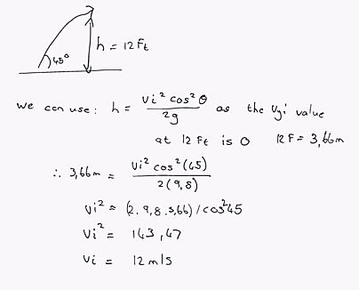
- If the motion begins at the highest point and falls to a point
  - Use the same steps as 1) however the equations to use are:
    - $y=v_{yi}t-\frac{1}{2}at^{2}$
    - $x=v_{xi}t$
Example: Water flows off a horizontal cliff 2,35m high at 1, 7 m/s. What is the horizontal distance covered before the water hits the ground.
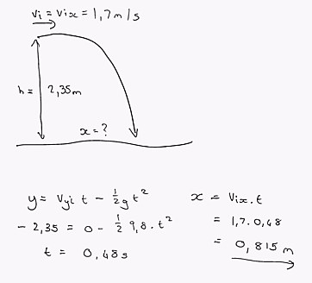

- If the motion starts and ends at the same horizontal level/plane
  - Use the same steps as 1) however the equations to use are:
    - $h=\frac{{v_{i}}^{2}sin^{2}\left(θ\right)}{2g}$
    - $R=\frac{{v_{i}}^{2}\sin\left(2θ\right)}{g}$
Example: An object begins and ends at the same horizontal level. Its maximum height is one third the magnitude of the total horizontal distance. At what angle was the object thrown?
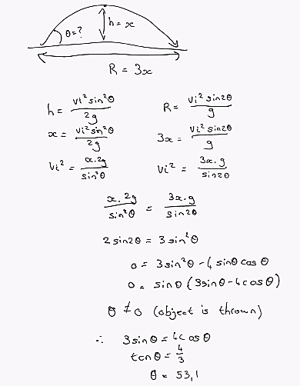
- If none of the previous cases apply
  - Draw a picture adding as much detain as possible
  - Use the equations
    - $x=v_{i}\cos\left(θ\right)t$
    - $y=v_{i}sin⁡(θ)t-\frac{1}{2}gt^{2}$
  - Solve these individually or simultaneously to obtain any variable
Example: A ball is kicked over a railing on top of a building and onto the rooftop. It is kicked at an angle of 53° at an unknown velocity. The building is 24m away and 6m high with a 1m high railing. The ball passes over the railing at 2.2s. What is (a) the value of V_{i}, (b) the vertical distance that the ball passes over the railing and (c) the horizontal distance that the ball passes the railing when it lands.

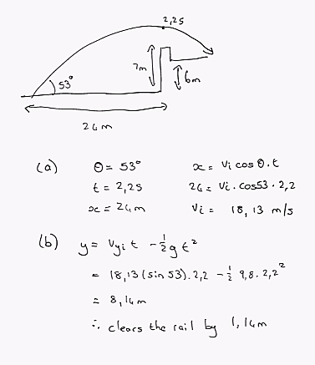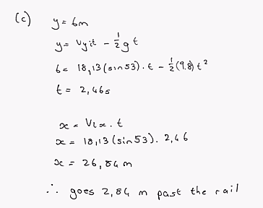

Uniform Circular Motion
v
v
v
r
- Velocity magnitude is constant
- Is uniform circular motion if
  - Constant speed
  - 2D circular path
- As velocity is constantly changing, there is acceleration

$\overline{∆r}=\overline{r_{f}} -\overline{r_{i}}$
$$\overline{v_{i}}$$
$\left|\overline{r_{f}}\right|=\left|\overline{r_{f}}\right|=r$ $$∆v=v_{f}-v_{i}$$
$$∆θ$$
$$\overline{v_{i}}$$
$$\overline{∆r}$$
$${\overline{r}}_{f}$$
$$\overline{r_{i}}$$
$$v_{f}=v_{i}=v$$
Because $∆v$ is tangential to the path, a is as well
$$∆r|||∆v$$
$∴\frac{\left|∆v\right|}{v}=\frac{\left|∆r\right|}{r}$ $$\left|a_{avg}\right|=\frac{\left|∆v\right|}{t}$$
$$\left|a_{avg}\right|=\frac{v\left|∆r\right|}{r∆t}$$
Find instantaneous velocity:
$$a=\frac{v}{r}.\frac{d\left|∆r\right|}{dt}$$
$a_{c}=\frac{v^{2}}{r}$ – Always directed perpendicular to the path towards the centre of the circle
- Period – time taken to make one revolution
  - $T=\frac{2πr}{v}$
- Angular speed – the rate at which the angle changes
  - $ω=\frac{v}{r}$
  - $∴a_{c}=r.ω^{2}$
Example:
In centrifugal casting, a copper sleeve of radius 2.20cm is created by spinning a tube with a centripetal acceleration of 100g. What rate of revolution is required?
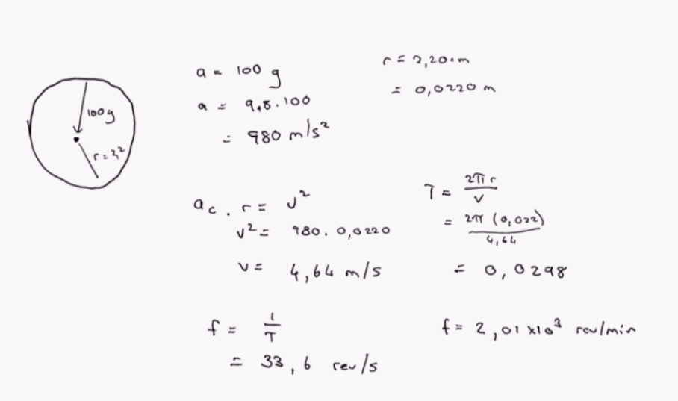

Laws of Motion

Concept of force
- Interaction between objects – motion as a result of force
- 2 Categories
  - Fundamental/fuel/non-contact forces
    - Gravitational forces (weakest)
      - Weight – gravitational force ($F_{g}=mg)$
    - Electromagnetic forces
    - Strong nuclear forces – between protons, neutrons and quarks (strongest)
    - Weak nuclear forces – plays a role in radioactive nuclei
  - Contact/non-fundamental forces
    - Normal force (N) - perpendicular to the contact surface
    - Applied force (${\overline{F}}_{appl})$- external object pushes or pulls another object
    - Tension (T) – found in objects joining two other objects (string)
      - The objects carrying tension are treated as massless
    - Spring force ($F_{s})$ – found in elastic objects
      - Example of a restorative force (returns to original shape)
    - Frictional forces $\left(f_{s}\right)\left(f_{k}\right)$ - microscopic bonding of two surfaces
      - Opposite to motion, parallel to the surface
      - Resistive force
      - Static friction $\left(f_{s}\right)$ – no relative motion between the objects
        - Can only calculate the maximum value
        - $f_{s}=μ_{s}N$
          - $μ_{s}$ – static friction co-efficient (unitless)
          - Constant according to material (types of contact surfaces)
          - $f_{s}$ – magnitude of force just before the object moves
      - Kinetic friction $\left(f_{k}\right)$ – between objects of relative motion and context
        - Less than static friction
        - Constant force
        - $f_{k}=μ_{k}N$
    - Drag force – force due to air resistance

Newton’s First Law
- Also called inertia
- Property of mass that causes it to resist being accelerated
- Easy to accelerate a small mass, hard to accelerate a large one
- Describes an object in equilibrium – motion of an object is constant
- Net force – when more than one force acts on an object, motion is determined by the vector sum of forces
  - ${\overline{F}}_{net }={\overline{F}}_{1 }+{\overline{F}}_{2 }+{\overline{F}}_{3 }$
  - ${\overline{F}}_{net }=\sum{\overline{F}}$
- Free body diagrams (FBD)
  - Represent the object as a particle and label it
  - Chose an appropriate co-ordinate system
  - Identify all the forces acting only on the one object
  - Draw the vector arrows, indicting direction but not magnitude
Example: A picture frame hangs on a wall supported by two strings. It has a mass of 200g. Calculate the tension in the strings.
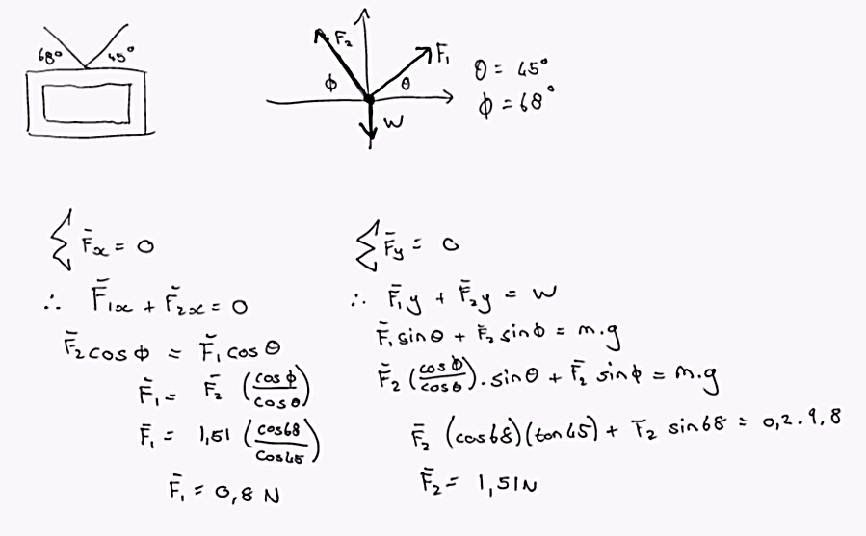

Newton’s Second Law
- An imperial law – found through experimentation and not derived from anything else
- Formula
  - $\overline{a}∝{\overline{F}}_{net }$
  - $\overline{a}∝ \frac{1}{m}$
  - ${\overline{F}}_{net }=m\overline{a}$ (where F_{net} and a point in the same direction)
- Second law deals with dynamic systems and changing motion
  - Can and should be broken down into the x,y and z components as with motion in 2 dimensions
  - It defines the unit Newton (N)
    - $1N=1kg.m/s^{2}$

Newton’s Third Law
- All forces exist as interaction pairs (action-reaction pairs)
  - The two forces are located on different objects
- ${\overline{F}}_{21}={-\overline{F}}_{12}$ (linear momentum is a result of this)

Example: Find the acceleration and contact forces between the boxes:
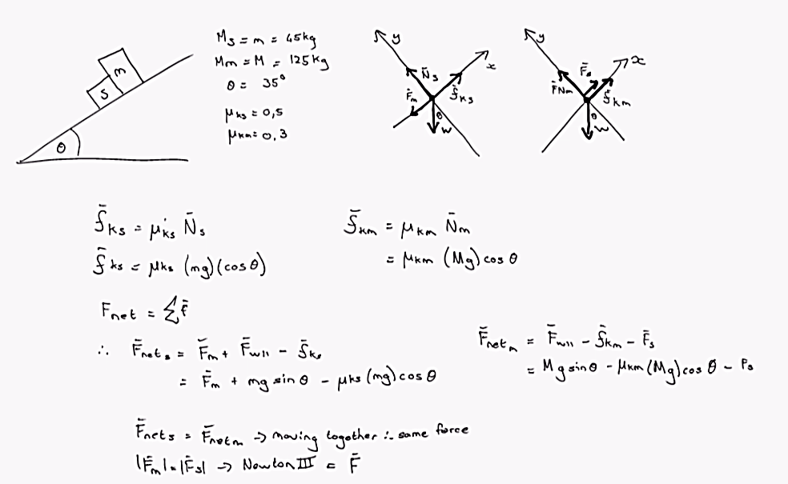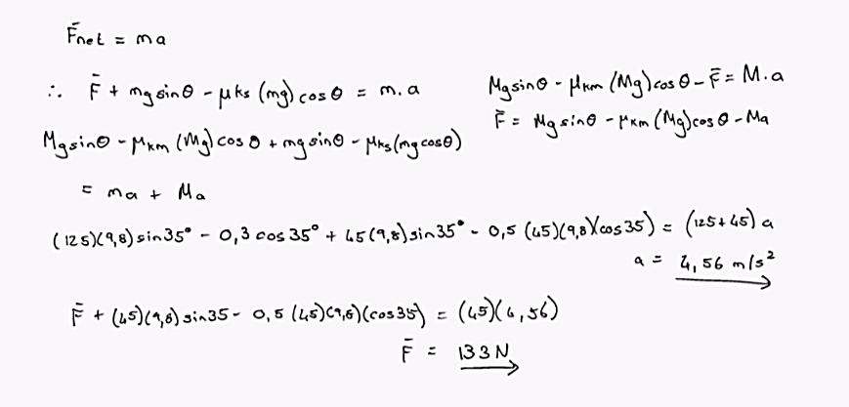

Chapter 6: Extension of Circular Motion

Extending Uniform Circular Motion
- We know that $a_{c}=\frac{v^{2}}{r}$, where a_{c} is directed into the centre of the circle
- Thus the F_{net} is also directed towards the circle centre
- Thus $\sum{{\overline{F}}_{r}}=m\frac{v^{2}}{r}$ (only calculates the magnitude)
  - This force changes the direction of the velocity vector and not the magnitude
- Examples of this force
  - Object tied with a string an circled in with a constant velocity – force is the tension within the string
  - Gravitational force (between a star and planet for instance)
  - Electrical force between an electron and a proton
- When calculating values for situations, you often have to freeze time and work with the forces only in that instance
Example 1: Conical pendulum. An object is fixed to a string length L and moved at a constant speed in a horizontal plane x,z in circle radius r. Find the speed (v) that it is traveling.
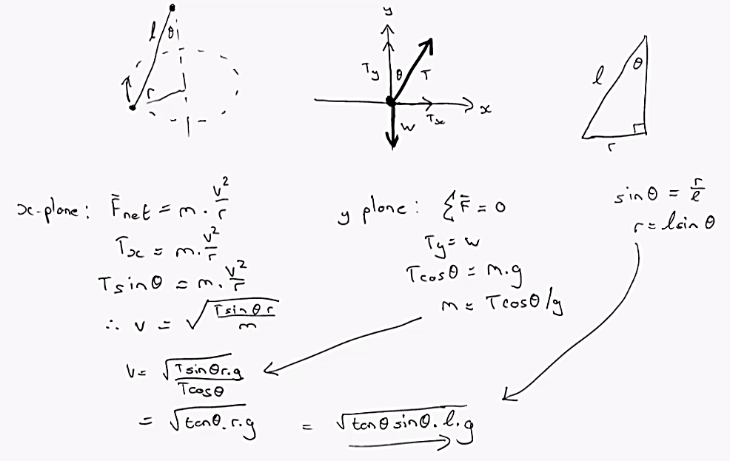
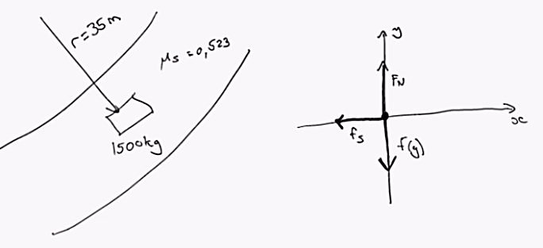
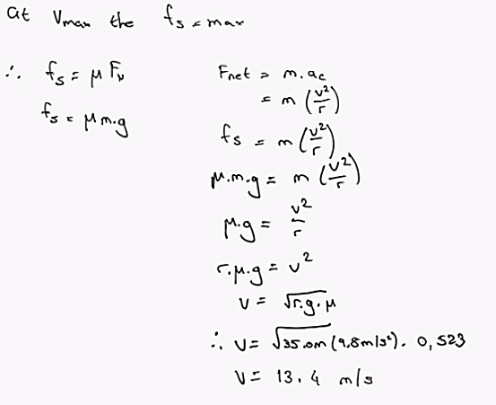
Example 2: A car travels around a corner with radius 35m. The co-efficient of static friction between the tires and the road is 0.523. What is the maximum speed that the car can travel round the corner before it begins to slip?

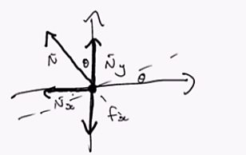
Example 3: A car travels around a banked corner of 35m at 13.4m/s. What angle must the slope be at to prevent the car from slipping in the absence of friction.
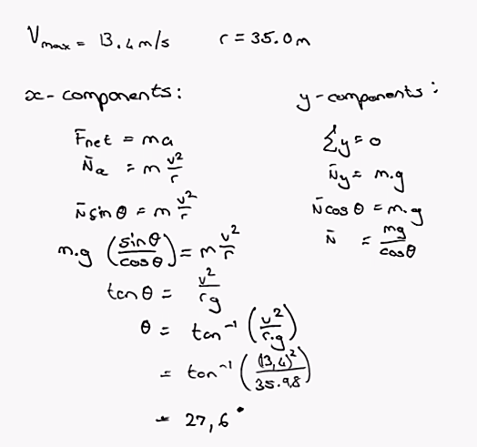

Non-Uniform Circular Motion
- For example an object spinning on a horizontal axis
- If the particle is not moving at a constant speed – this implies acceleration = $\frac{\left|dv\right|}{\left|dt\right|}$
Thus there is both a tangential force applied as well as a radial force: $F_{net}=F_{radial}+F_{tangential}$
Thus the total acceleration is applied in the same direction as the net force
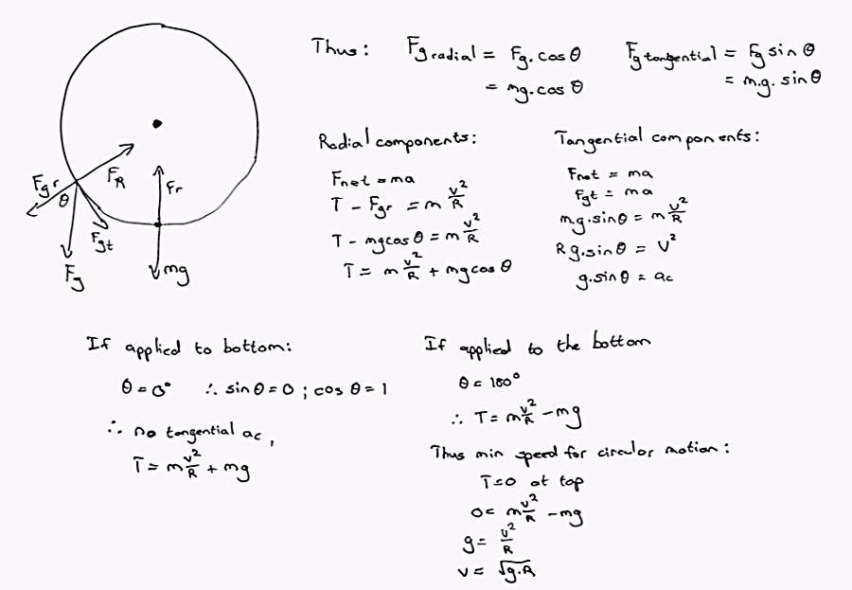
- If gravity is the force causing the tangential acceleration:

Drag Force
- Force that opposes the motion of an object
- $\vec{R}=-b\vec{v}$
  - Thus the drag force for small objects is directly proportional to its velocity
  - When doing calculations, just factor in the extra force vector for the drag force
  - The terminal speed of an object can be calculated using $v_{t}=\frac{mg}{b}$ (determined by making the forces equal – no acceleration)
- With larger objects the force is proportional to the velocity squared
  - In free fall can use equation: $R=0.5DpAv^{2}$
    - D – drag co-efficient
    - P – density of air
    - A – cross section of the object perpendicular to motion

Chapter 7: Energy of a System

Systems and Environments
- A system is a small part of the universe
  - Always surrounded by an imaginary boundary
  - Outside the boundary – environment

Work done by a constant force
- If a constant force is applied and the object is displaced in the direction of the force, then the force did work
- $w=\overline{F}.\overline{r}.cosθ$
  - Θ – angle between F and r
  - W – scalar quantity
- Form of equation tells us
  - Forces perpendicular to the motion do not do work
  - Projection of F in direction r is doing the work
  - If the force is acting in the opposite direction to the motion, then negative work is done
- Work has a sign but no direction
- Unit (Jules) – kg.m²s⁻²
- Work is an example of energy transfer
  - If w > 0 then work is done on the system by the environment – energy is transferred into the system
  - If w < 0 then work is done by the system on the environment – energy is transferred out of the system

Scalar product of two vectors (dot product)
- Written as $\overline{A}.\overline{B}$
- Definition $\overline{A}.\overline{B}=ABcosθ$
  - Θ – the smaller angle between a and b
  - Thus Bcosθ is just the projection of B in the direction of A
- Properties
  - Is commutative - $\overline{A}.\overline{B}=\overline{B}.\overline{A}$
  - Distributive – $\overline{A}\left(\overline{B}+\overline{C}\right)=\overline{A}\overline{B}+\overline{A}\overline{C}$
  - If A is perpendicular to B then the product is 0
  - Any two products of direction indicators (hats) equals 1
    - $\hat{i}.\hat{i}=\hat{j}.\hat{j}=\hat{k}.\hat{k}=1$
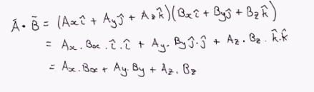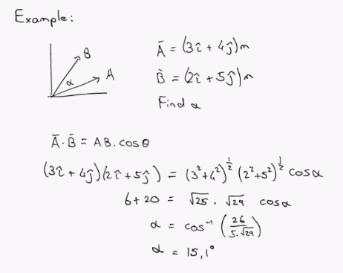

Work with a varying force
- $w=\overline{F}.\overline{r}$
- Thus if force becomes a function (e.g. $F=x+2)$, then work will be the integral of the force in terms of the change in direction
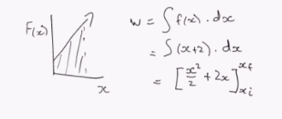
- If there are multiple forces (constant forces) there are two options
  - Sum of the work done by each force – calculate the work done for each force in each direction and then add them
  - Find the net force and then solve
- If working with option 1 and forces in multiple dimensions
  - $W_{net}=\int_{ri}^{rf}{\sum{\overline{F}\left(\overline{r}\right).d\overline{r}}}$
  - In this case the integral is called a line integral and its value is calculated using the path followed and not the total displacement
- Such 2D examples are not tested on changing forces
- If a graph is given, find work by finding are under the line

Work done by a spring
- A spring under applied force can either be stretched or compressed from equilibrium
- Force applied by the spring is: $F_{s}=-kx$
  - K is the spring constant in N/m
  - The negative sign indicates that the force applied by the spring acts in the opposite direction to the displacement
  - Also called Hooke’ Law
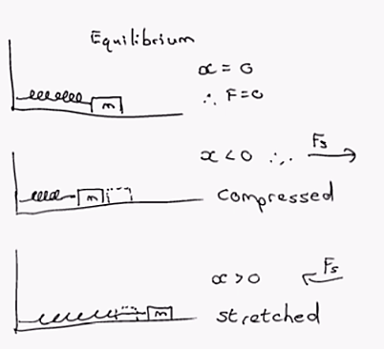
- If we compress the spring to x = -x_{max} and release it, we can calculate the work done by the spring from –x_{max} to 0
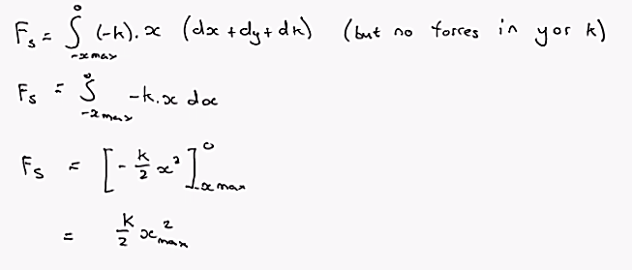
- Similarly if the spring is moved to x = x_{max} then
  - $w=\frac{-k}{2}x_{max}^{2}$
- Thus the net work from –x_{max} to x_{max} will equal zero
- In general
  - $w=\int_{xi}^{xf}{-kx.dx}$
  - $w=-\frac{k}{2}x_{i}^{2}+\frac{k}{2}x_{f}^{2}$
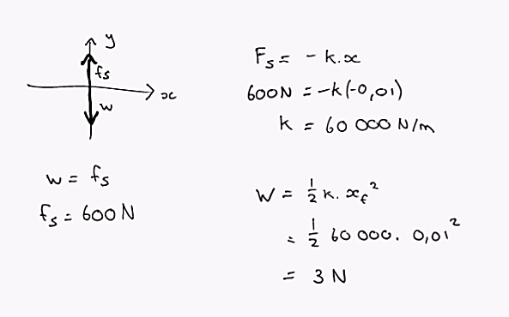
Example: A man weighing 600N steps on a scale. The spring is compressed by 1 cm. Find the spring constant and the work done by the man’s weight.

Potential Energy of a System
- Energy stored in position – potential energy
  - Position relative to another object
  - Both objects have to exert a force on one another
- Gravitational potential energy
  - Change relative to earth (height)
  - Must assign the point where h=0 (the origin) at beginning
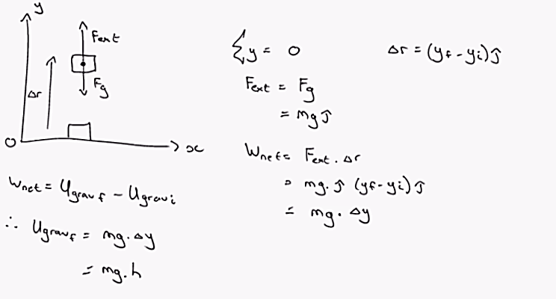
Example: An object of mass 1.8kg is attached to the ceiling of a room by a string 1.2m. The room is 2.8m high. What is the gravitational potential energy relative to:
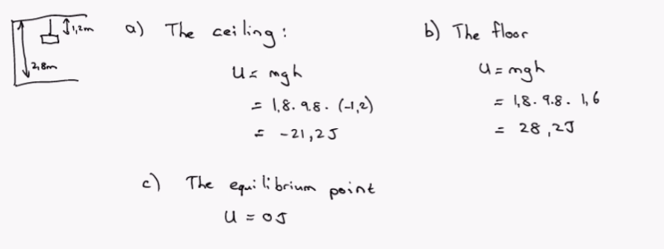
- Elastic potential energy
  - If we deal with a spring and a block, the two members interact with one another in a spring force
  - Thus similarly proved earlier:$w=-\frac{k}{2}x_{i}^{2}+\frac{k}{2}x_{f}^{2}$
  - $∴U_{spring}=U_{elas}=\frac{k}{2}x_{f}^{2}$

Conservative and non-conservative forces
- Conservative force – work done on the particle when it moves over displacement is independent of the path taken
  - Depends only on the initial and final points in space
  - Implies that there are no resistive forces acting on the object as it covers ground
  - Work on a closed path is zero
  - The equations using work due to gravity and springs are examples of conservative forces
- Non conservative forces – any force which does not fulfil the above properties
  - Work done is path dependant e.g. frictional force
  - Mechanical energy will be changed by non-conservative forces
    - Will not be changed by conservative forces

Relationship between conservative forces and potential energy
- The work done depends only on the initial and final positions of the object
- For such a force, a function can be derived
  - $w_{int}=w_{cons}=-∆U$
  - Energy is lost as an internal object is using energy within the system to create force
- Any force in the x direction displaces an object in that direction
  - Thus $U=-\int_{xi}^{xf}{Fx.dx}$
  - If ΔU is negative then F_{x} and Δx are in the same direction
  - If ΔU is positive then F_{x} and Δx are in opposite directions
  - Could also be written as: $F_{x}=-\frac{dU}{dx}$

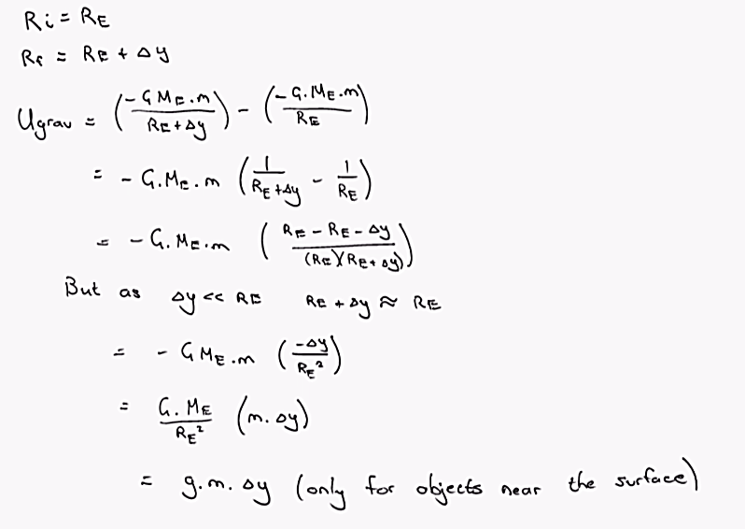
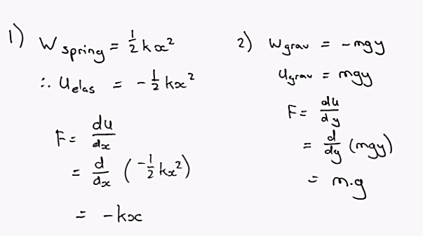
Gravitational Potential Energy
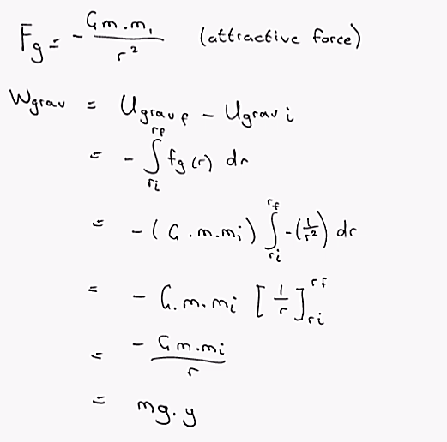

Chapter 8: Conservation of Energy
- Conservation Law – the quantity does not change its value with time
- Law of conservation of energy total energy in the universe is unchanged by physical processes. Energy cannot be created or destroyed. Can only be transferred from one type to another
- Forms of energy: chemical, nuclear, elastic etc.
- Fundamental level – 2 types
  - Kinetic – energy stored in motion
  - Potential – energy stored in position
- Third type – internal energy – the total energy of the object when at rest

Non Isolated System
- In a non-isolated system, energy can cross the system boundary over time due to interaction with the environment
  - Occurs due to work/ mechanical waves/ electromagnetic radiation/ electric transmission/ heat
- Total energy only changes when energy crosses the boundary
  - $∆E_{system}=\sum{E_{transfer}}$

Isolated system
- Chose a system in such a way that no energy crosses the boundary by any method
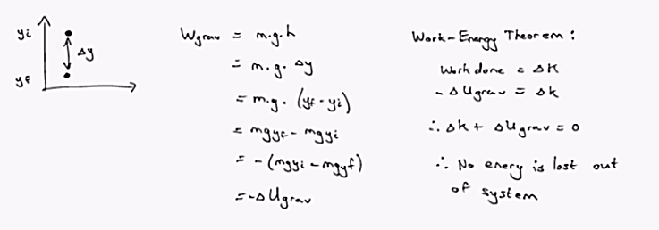Mechanical energy = U + K
  - $E_{mech}=K+U$
  - $∆E_{mech}=0$
- Thus
  - $E_{mech,i}=E_{mech,f}$
  - $K_{i}+U_{i}=K_{f}+U_{f}$
Example: Three objects with mass m₁ = 5kg, m₂ = 10kg and m₃ = 15kg are attached by weightless ropes over frictionless pulleys as in the figure. The horizontal surface is frictionless and the system is released from rest. Find the speed of m₃ after it has moved 0.4m down.
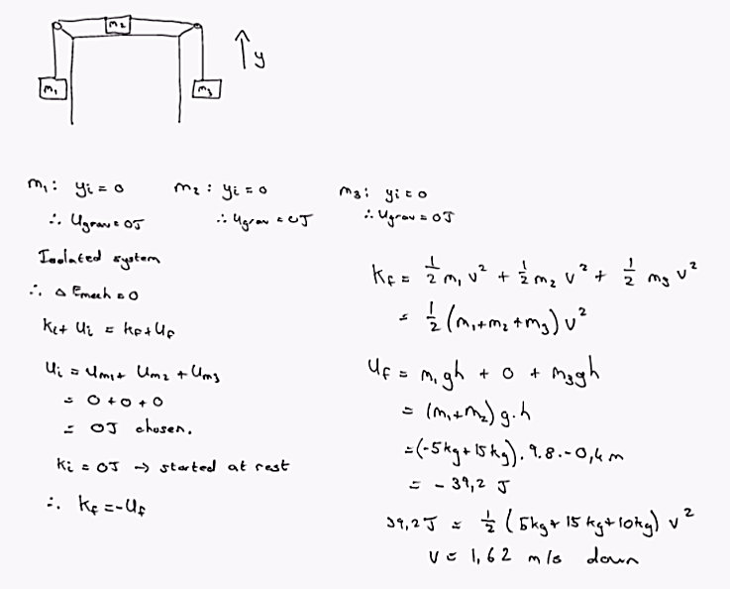
Example 2: A bungee jumper jumps from a 75m bridge. He has a mass of 80kg and a height of 1.85m. We treat the bungee cord as a spring with constant k = 50N/m. Assume the cord is massless. Calculate the maximum length of the cord that can safely be used.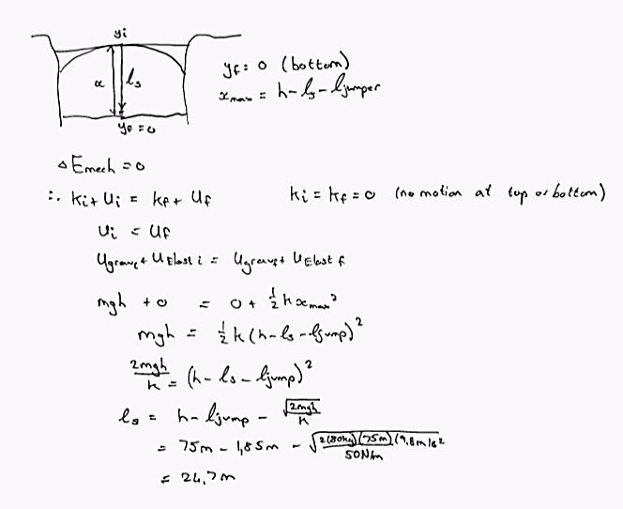

Situations involving friction
If we have an object that slides over a surface with a path (d) we can determine the work done by kinetic friction and other forces.
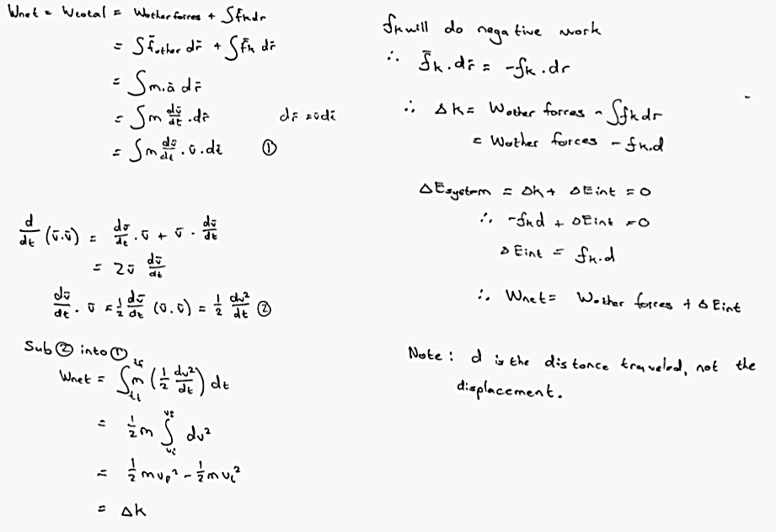
Example: A 200g block is pressed up against a spring with a constant 1400 N/m until it is compressed 10cm. The spring rests at the bottom of a 60° slope. The coefficient of kinetic friction is 0.4. How far up the slope does the block travel upon release?
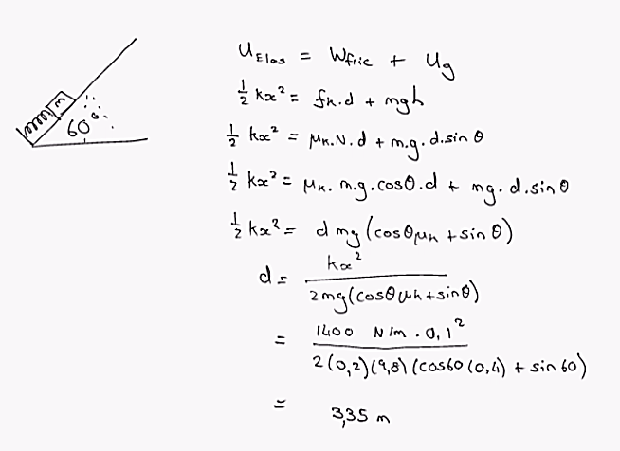

Power
- Power is the rate at which work is done
- $P_{avg}=\frac{W}{t}$
- $P=\frac{dW}{dt}$
- $P=\overset{⃑}{F}\overset{⃑}{v}$
- 1hp = 746W

Chapter 9 – Linear Momentum

Linear Momentum
In an isolated system (no external forces act on the system) of two particles that interact with one another.
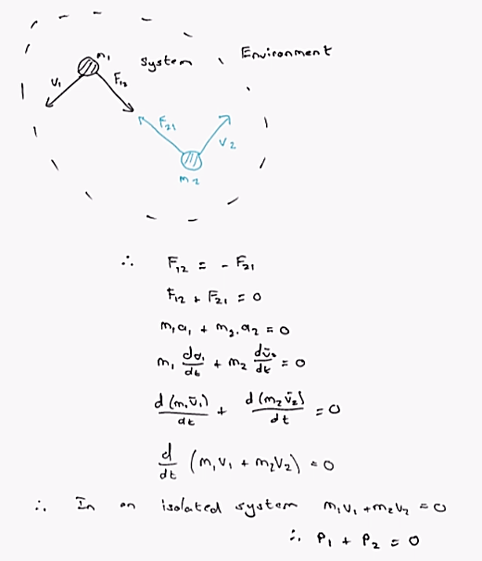
- P = m.v
- Impulse – the rate of change of momentum
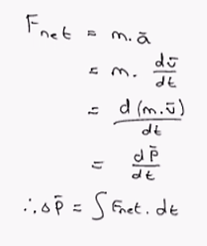
- If momentum is conserved (is always in theory) then
  - $m_{1}v_{1i}+m_{2}v_{2i}=m_{1}v_{1f}+m_{2}v_{2f}$
- Impulse-momentum theorem – the change in momentum is equal to the impulse
  - I = ΔP

Momentum in a non-isolated system
- Momentum is transferred to the system from the environment by a net force
- Impulse is the degree to which a net force changes the momentum of a particle
  - $I=\int{F.dt}$
  - Impulse is equal to zero in an isolated case
Example: A car is moving at 20m/s and then crashes into a tree. Find the magnitude of the average force acting on a passenger of mass 65kg in the following cases.
- The passenger is not wearing a seatbelt and is brought to a stop by collision with the windscreen in 3ms.
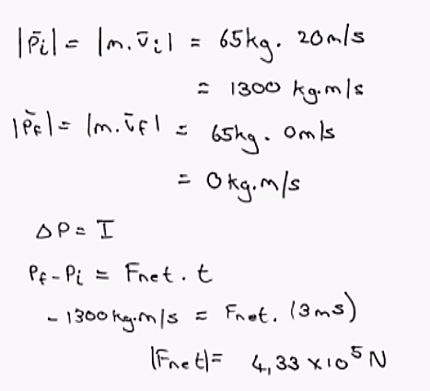
- The car is equipped with airbags and the force acted by the airbag acts for 30ms before the passenger comes to rest.
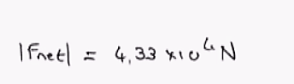

Collisions in 1D
- Collision – event where two particles are close to one another and interact via forces
- Inelastic collisions
  - Linear momentum is conserved
  - Kinetic energy is not conserved
Example: Rubber ball falls to the ground and only returns to half its previous height – occurs due to ball deformation
  - Perfect inelastic collision
    - Two colliding objects stick together during the collision
    - Creates a composite object
    - Final speed is the same for both objects
      - $v=\frac{m_{1}v_{1i}+m_{2}v_{2}i}{m_{1}+m_{2}}$
      - If the second object is much greater in mass and initially at rest then it will not move
- Elastic collisions
  - Linear momentum and kinetic energy are conserved
  - Example: Hard spheres like golf balls
Proof of elastic energy equations
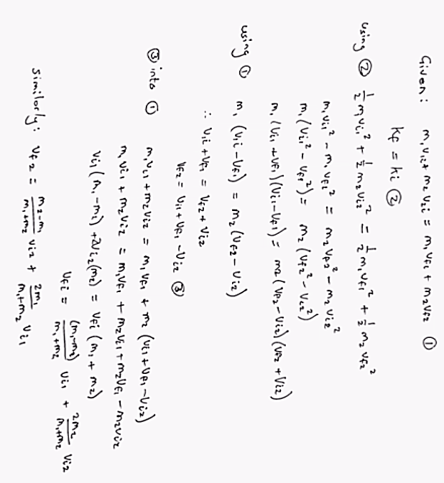
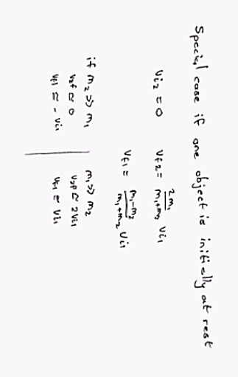

Collisions in 2D
- The momentum is conserved in all of the x, y and z directions
- Therefore break the momentum into its components and solve individually
Example: 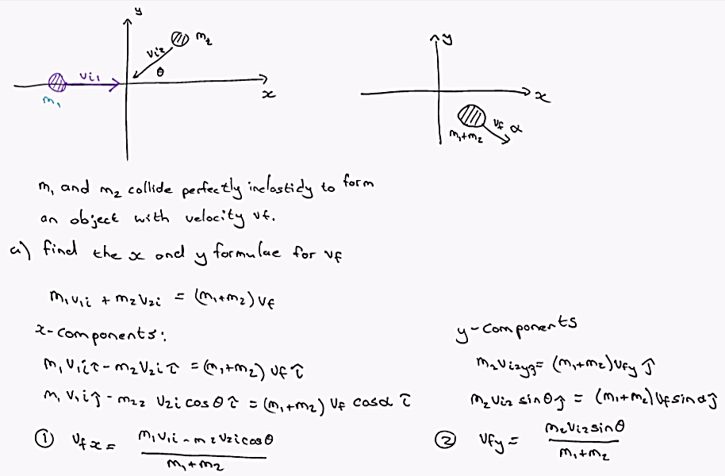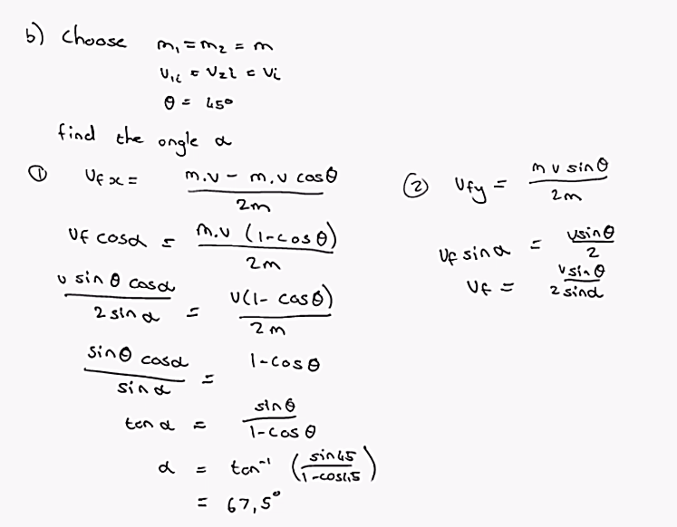

Centre of Mass
- The average position of the systems total mass
- Using any system of many particles:
  - Formula - $x_{cm}=\frac{\sum_{i=1}^{n}{m_{i}x_{i}}}{M}$
  - For 2 or 3D cases, divide the equation into an x, y and z centre of masses

Example:
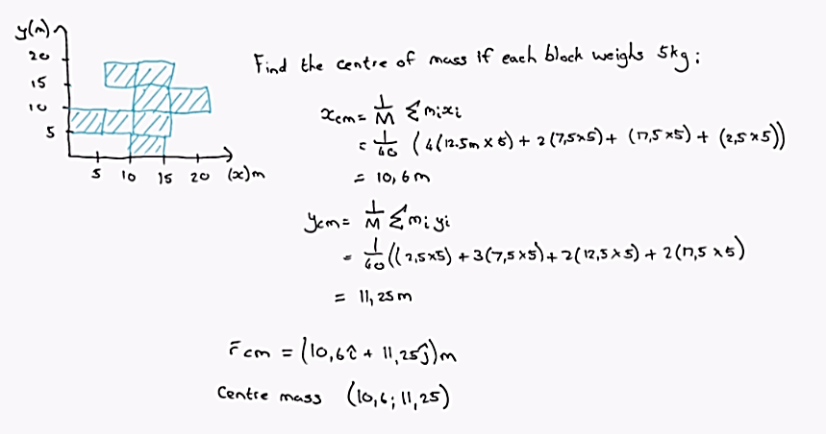
- For solid objects
  - Square – in the middle of the sides
  - Circle – in the centre
  - Right angled triangle – 1/3rd in closest to the largest side (for both x and y)
Example:
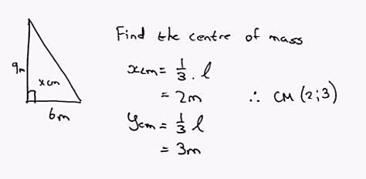

System of Many Particles
- When dealing with a system in motion of more than 2 particles:
  - Find the centre of mass
  - Use the centre of mass as the point from which all motion calculations are used
- Or
  - Use the centre of mass velocity - $v_{cm}=\frac{\sum_{i=1}^{n}{m_{i}v_{i}}}{M}$
  - The product of the mass and velocity of the centre of mass gives the total linear momentum
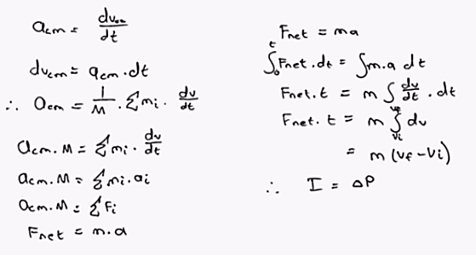
Proofs:

Example: A 2000kg car just started moving forward when it was struck from behind by another car of 1000kg. The bumpers of the two cars become entangled and the cars move forward until they come to rest 3m from where the first car pulled off. The first car was moving at 5m/s just before the collision. Did the second car exceed the 60km/h speed limit? Assume the friction between the road and the tires to have a coefficient of 0,8.
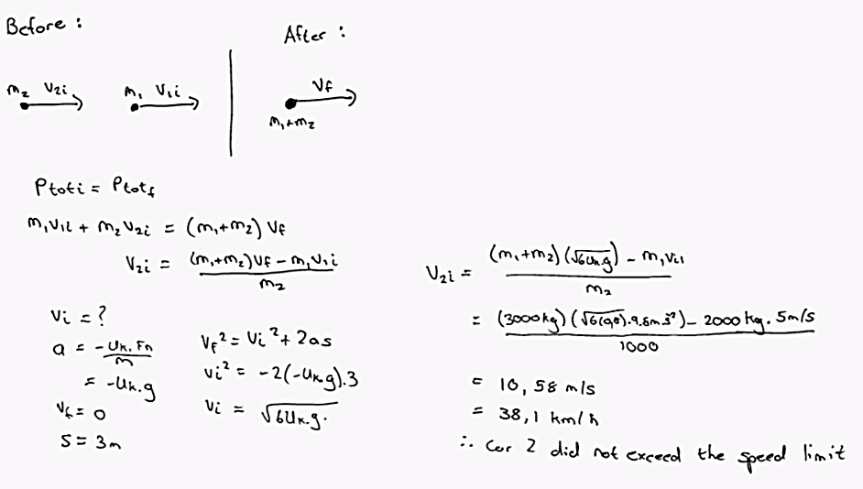

Chapter 10 – Rotation of Rigid Objects
- Chapter deals with objects that cannot be treated as single particles
- Different parts will have different velocities and accelerations - system of particles
- Rigid object – non-deformable/ relative locations of different parts is constant

Angular position, velocity and acceleration
- A point is represented by polar co-ordinates (r;θ)
- As p rotates, it creates an arc length – S
  - S = θr
  - Θ – dimensionless number in radians
  - It is the angular position – the angle between a line connecting the origin and the point and a fixed reference point
  - Δθ – angular displacement, the change in angle over time
- Angular speed (ω) – rate of change of angle
  - $ω=\frac{dθ}{dt}$
  - Positive value – θ is increasing in the counter clockwise direction
  - Negative – decreasing in clockwise direction
  - Right hand rule – use fingers to indicate direction of motion and thumb to indicate direction of speed
    - Will have a direction that goes into or out of the page
    - If speed is increasing then α will have the same direction as ω
    - If speed is decreasing then α will have the opposite direction to ω
- Angular acceleration (α)
  - $α=\frac{dω}{dt}$
  - α and ω are the magnitude quantities of the vectors
- Angular displacement has definite direction but is not a vector
  - Does not obey addition laws

Rigid object under constant angular acceleration
- Equations
  - $ω_{f}=ω_{i}+α.t$
  - ${θ_{f}=θ_{i}+\frac{1}{2}\left(ω_{f}+ω_{i}\right)}_{ }t$
  - $θ_{f}=θ_{i}+ω_{i}.t+\frac{1}{2}\left(α.t^{2}\right)$
  - ${ω_{f}}^{2}={ω_{i}}^{2}+2α\left(θ_{f}-θ_{i}\right)$
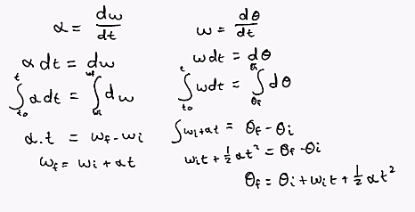
- Only apply for constant acceleration
- Other equations derived through substitution

Relationship between translational and angular quantities
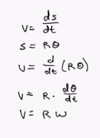
- Translational velocity – tangential to the circular path of the point considered
  - $v=rω$

  - Every point on the object has the same angular speed but a different tangential one
- Tangential acceleration
  - Derived in the same manner as velocity
  - $a_{t}=αr$
- Radial acceleration
  - $a_{t}=\frac{v^{2}}{r}=\frac{{\left(ωr\right)}^{2}}{r}=ω^{2}r$
- Total translational acceleration
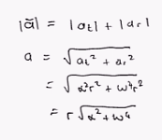
  - Radial + tangential

Example: A potter’s wheel accelerates from rest to 210rpm in 0.75s.
- What is the angular acceleration of the wheel during the time assuming constant angular acceleration?
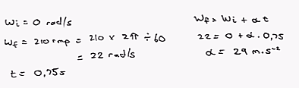
- How many revolutions does the wheel make during this time?
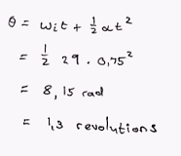
- Find the tangential and radial components of the translational acceleration of a point 12cm from the rotational axis when the wheel spins at 180rpm?
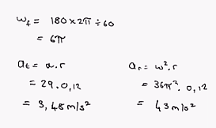

Torque
- D – the movement arm/ lever arm
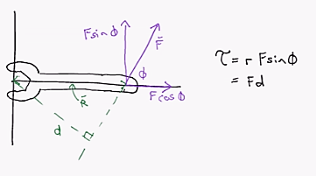
- Torque is a vector quantity with magnitude as defined above and a specific direction
- Torque as a vector quantity is given as: $τ=r×F$
- Torque is the amount of force, used to/ required to turn an object
  - Thus only the tangential component of the force acting on the object influences it
  - Hence $τ=rFsin\left(φ\right)$
- Net torque is measured as the sum of all the forces times their individual radii
  - $τ_{net}=r_{1}F_{1}+r_{2}F_{2}$

Cross Product
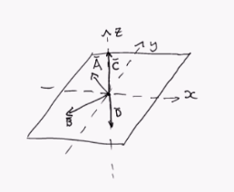
- $\vec{C}=\vec{A}×\vec{B}$
          - C – lies in the z plane (at 90° to the other vectors)
          - Use the right hand rule to calculate its direction – moving from fist multiplyer (A) to the second one (B)
- $\vec{D}=\vec{B}×\vec{A}=-\vec{C}=-\vec{A}×\vec{B}$
          - Direction is dependent on the order of the vector product
- $\left|\vec{C}\right|=ABsin(φ)$
- Vector will often point into or out of the page
- Properties
  - $\vec{A}×\vec{B}=-\vec{B}×\vec{A}$
  - $\vec{A}||\vec{B}→$ $\vec{A}×\vec{B}=0$
  - $\vec{A}⦜\vec{B}→\left|\vec{A}×\vec{B}\right|=AB$
  - $\vec{A}×\left(\vec{B}+\vec{C}\right)=\left(\vec{A}×\vec{B}\right)+\left(\vec{A}×\vec{C}\right)$
  - $\frac{d}{dt}\left(\vec{A}×\vec{B}\right)=\frac{d\vec{A}}{dt}\vec{B}+\frac{d\vec{B}}{dt}\vec{A}$
- Unit vectors (Hats)
  - $\hat{i}×\hat{i}=\hat{j}×\hat{j}=\hat{k}×\hat{k}=0$
  - $\hat{i}×\hat{j}=-\hat{j}×\hat{i}=\hat{k}$
  - $\hat{k}×\hat{i}=-\hat{i}×\hat{k}=\hat{j}$
  - $\hat{j}×\hat{k}=-\hat{k}×\hat{j}=\hat{i}$
- Procedure for calculating:
  - $\vec{A}×\vec{B}=\left[\begin{matrix}\hat{i} & \hat{j} & \hat{k} \\ A_{x} & A_{y} & A_{z} \\ B_{x} & B_{y} & B_{z}\end{matrix}\right]$
  - $\vec{A}×\vec{B}=\hat{i}\left(A_{y}B_{z}-A_{z}B_{y}\right)+\hat{j}\left(A_{z}B_{x}-B_{z}A_{x}\right)+\hat{k}\left(A_{x}B_{y}-A_{y}B_{x}\right)$

Example:
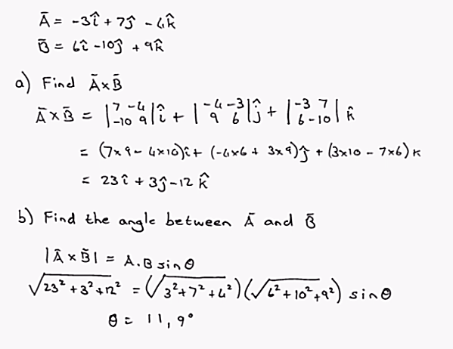

Rigid Object under Torque
- If an object is accelerating on a circular path
  - Has both an F_{t} and an F_{r}
  - $\sum{τ}=ma_{t}r$
  - $a_{t}=αr$
  - $I=mr^{2}$
- If an object is irregular then it can be divided into many small parts of mass m_{i}
  - Moment of inertia – calculated through $I=\sum{m_{i}{r_{i}}^{2}}$
  - This can be used to calculate systems with many individual masses
  - Won’t need to calculate moment of inertia of irregular objects using the integral method
- $τ=αI$
  - I – the moment of inertia – the equivalent of mass in linear movement
  - Acts as a form of resistance to motion
  - As I is constant for the location of the turning axis, it does not matter what shape the object is in so longs as its mass remains constant
  - Therefore, this equation always applies
Table indicating common rigid objects and their moments of inertia
Thin cylindrical shell | $$I_{cm}=MR^{2}$$ | Hollow cylinder | $$I_{cm}=\frac{1}{2}M(R_{i}^{2}+R_{o}^{2})$$
Solid cylinder | $$I_{cm}=\frac{1}{2}MR^{2}$$ | Rectangular plate | $$I_{cm}=\frac{1}{12}M(l^{2}+w^{2})$$
Long thin rod (middle rotation) | $$I_{cm}=\frac{1}{12}ML^{2}$$ | Long thin rod (end rotation) | $$I_{cm}=\frac{1}{3}ML^{2}$$
Solid sphere | $$I_{cm}=\frac{2}{5}MR^{2}$$ | Thin spherical shell | $$I_{cm}=\frac{2}{3}MR^{2}$$

Example: Two masses M₁ = 5kg and M₂ =7kg lie in the following configurations turning around the y axis. Find the moment of inertia.
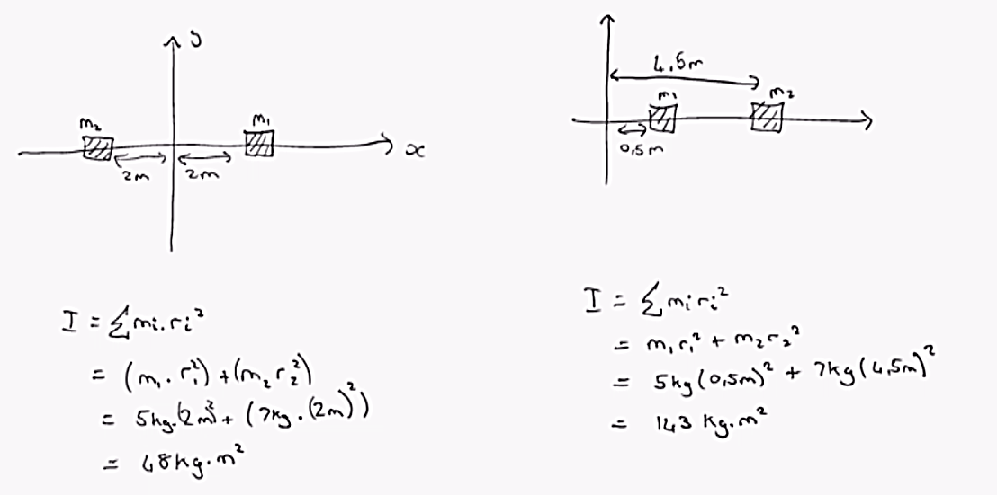

Example: If m₁ = 20.0 kg, m₂ = 12.5 kg, R = 0.200m, M = 5.00kg, what is the time required for m₁to hit the floor if m₁is 4.00m above the floor and m₂ on the floor when the system is released from rest?
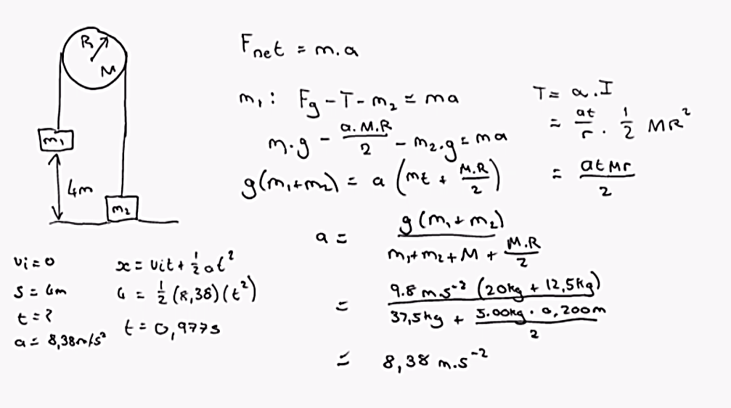

Calculation of Moment of Inertia
- Parallel axis theorem
  - If any object of mass M, with a known moment of inertia, turns round any axis then a new moment of inertia can be calculated for any new axis parallel to the original
  - $I=I_{cm}+MD^{2}$
  - $New I=Old I+Mass ×Distance between two axis^{2}$
Example: 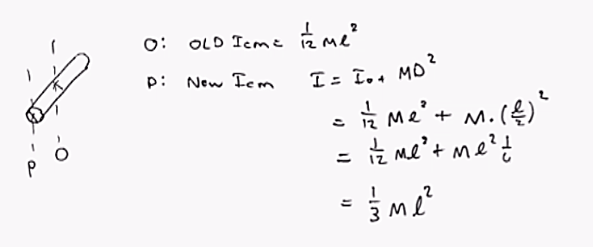

Rotational Kinetic Energy
- Kinetic energy normally is:
  - $K_{i}=\frac{1}{2}m_{1}{v_{i}}^{2}$
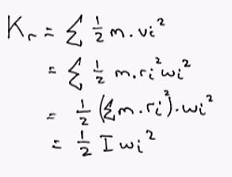
  - However this is the energy held by an individual particle and no by the whole object

Example: Four particles are connected with rigid rods of negligible mass. The origin is at the centre of the rectangle. The system rotates about the z-axis with angular speed 6.00 rad/s. Find (a) the moment of inertia and (b) the kinetic energy.
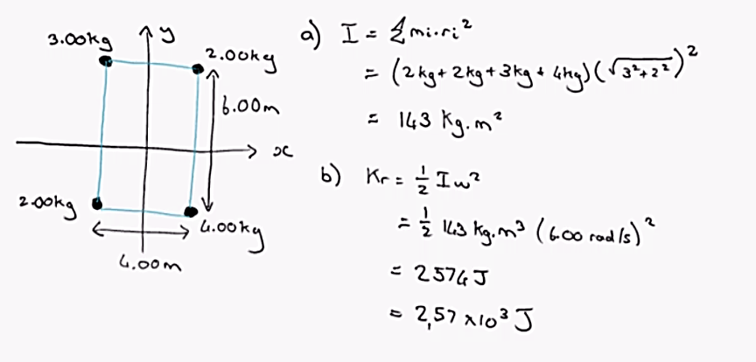

Energy Considerations in Rotational Motion
- Work done by a rotating object
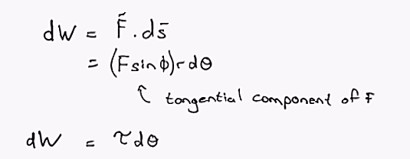
- Power delivered by a rotating object

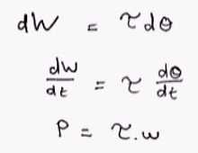

- Proving work energy theorem
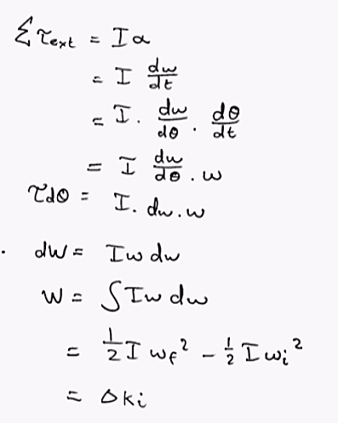
Example: Consider 2 objects with m₁ > m₂ connected by a light string and passed over a pulley. The pulley has no friction and a moment of inertia I when using radius R. The two objects are released from rest separated by a vertical distance of 2h. Find (a) the translational speed of the objects as they pass each other and (b) the angular speed of the pulley at the same time.
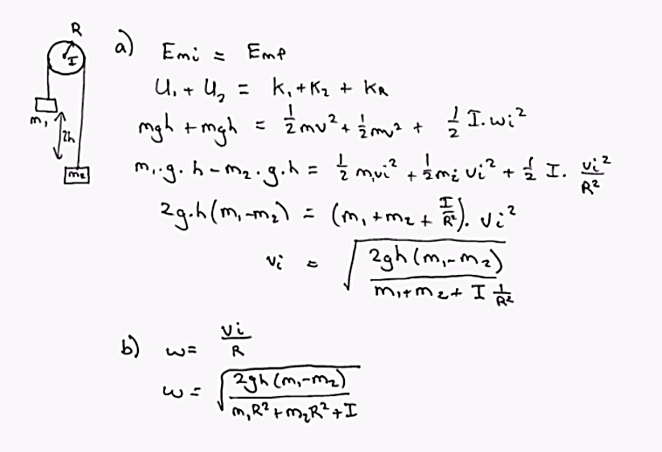

Chapter 15: Oscillatory Motion

Simple Harmonic Motion of an Object attached to a spring
- If an object is attached to a spring on a frictionless surface
  - Hooke’s Law: $F_{s}=-kx$
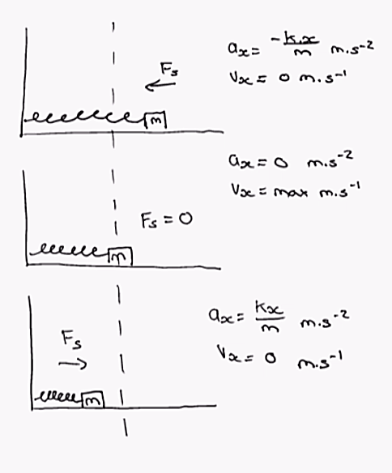
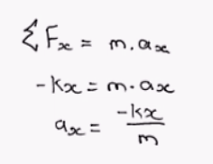
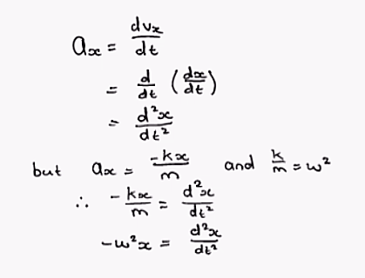
- Using Newton’s second law:

- Determining an equation for x(t) – using differential equations
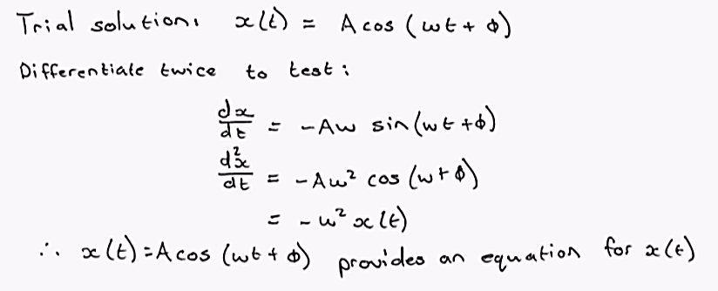
  - A – the maximum amplitude (distance from point of equilibrium)
  - ω – angular frequency
  - φ – phase constant (determined by the point at which the time starts) – where the object is released
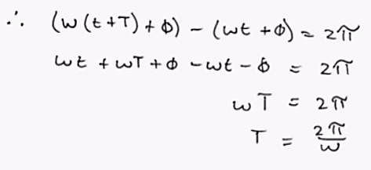
  - x(t) is a periodic function that repeats for every value of ωt = 2π
  - T – the time required for a full cycle of rotation to occur

- Frequency (Hz) – the inverse of T
  - $f=\frac{1}{T}=\frac{ω}{2π}$
- Equations for determining velocity, acceleration
  - $x\left(t\right)=Acos\left(ωt+φ\right)$
  - $v\left(t\right)=-ωAsin\left(ωt+φ\right)$
  - $a\left(t\right)=-ω^{2}Acos\left(ωt+φ\right)$
  - $v_{max}=ωA=\sqrt{\frac{k}{m}}A$
  - $A_{max}=ω^{2}A=\frac{k}{m}A$
- Using initial conditions to determine φ
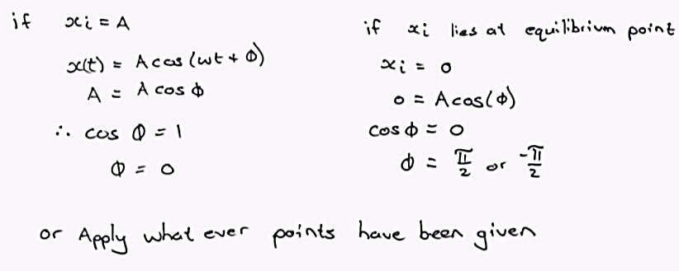
Example: A particle moves along the x-axis. It is initially at the position 0.270m moving with velocity 0.140m/s and acceleration -0.320m/s². Suppose it moves as a particle under simple harmonic motion for 4.50s and x=0 as an equilibrium position. Find its position and velocity at the end of the time interval.
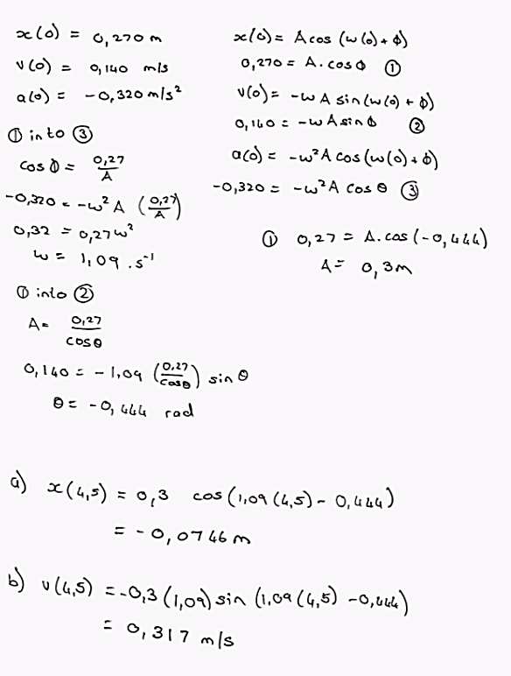

Energy for Simple Harmonic Motion
- If the system is frictionless
  - Mechanical energy is conserved
  - $E_{mech}=K+U$
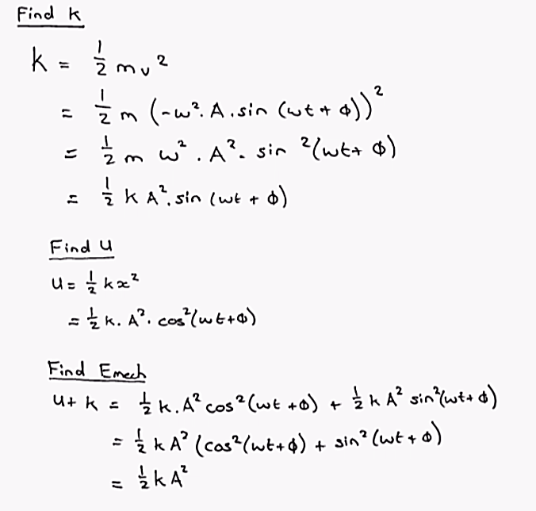
- $\frac{1}{2}kA^{2}=\frac{1}{2}{kx}^{2}+\frac{1}{2}{mv}^{2}$
  - Can be simplified to: $v=±ω\sqrt{A^{2}-x^{2}}$
Example: A 500g block is attached to a spring and is pulled a distance of 20cm from the equivalent position and then released. The subsequent oscillations are measured and a period of 0.8 s is found. At what position is the blocks speed 1.0m/s?
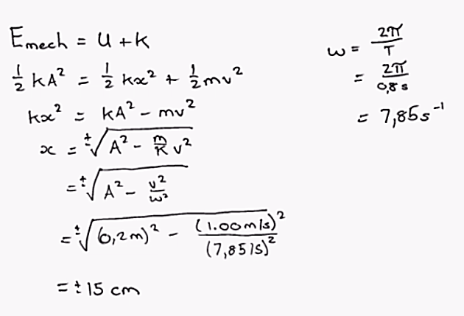

Relationship between SHM and Circulatory Motion
- The equations from SHM can be seen and derived fairly easily from circular motion
- X-displacement
  - As point P rotates around the circle, q moves back and forth in the motion:
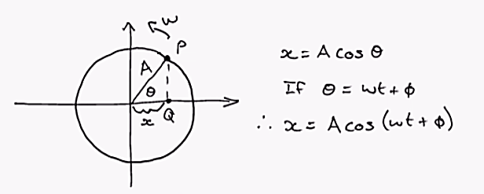
- Velocity
  - Divide tangential velocity into components and solve for the x-component
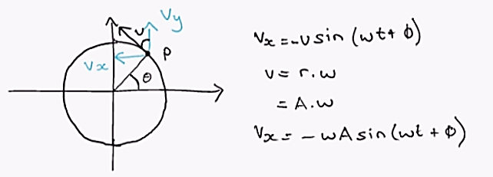
- Acceleration
  - Draw in the centripetal acceleration
  - Divide into its components and solve for the x-component
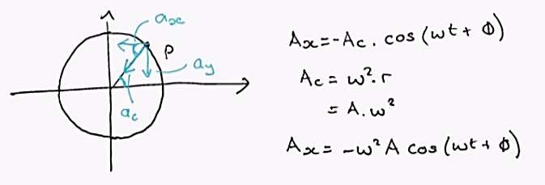

The Pendulum
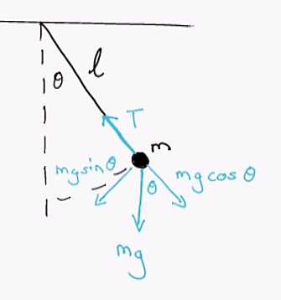
- When using a simple pendulum
          - The tangential component of weight will always point towards θ = 0 (vertical)
          - Thus acts like a restoring force
- A simple pendulum must be a “massless” rod with a single mass on the end otherwise must be treated as a physical pendulum

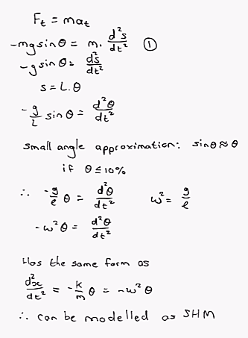
- Equation for a pendulum using SHM
  - $θ=θ_{max}\cos\left(ωt+φ\right)$
- Period
  - $T=\frac{2π}{ω}=2π\sqrt{\frac{l}{g}}$
Example: A grandfather clock uses a pendulum with period 2.0s. It has a mass of 150g and is displaced by 33mm horizontally.
- Find the length of the pendulum.
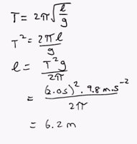
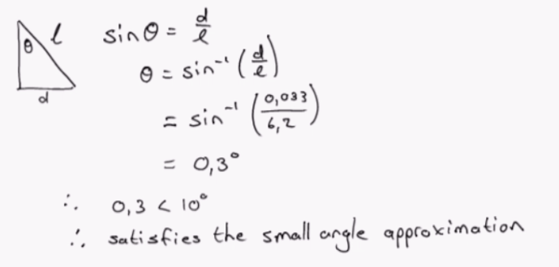
- Does the initial displacement of the mass satisfy the small angle approximation?

Physical Pendulum
- Used when the dimensions and mass of the actual pendulum rod are given
  - Model it using many equations derived in torque section
  - Especially prevalent use of moment of inertia
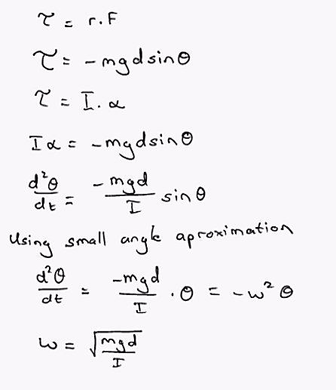
- $T=2π\sqrt{\frac{I}{mgd}}$
  - D – the distance between the point of rotation and the entre of mass
- $θ=θ_{max}\cos\left(ωt+φ\right)$
  - Uses a different ω, otherwise identical to the simple pendulum equation
Example: A rod of uniform mass 2.00kg and length 3.00m lies at the horizontal and is then dropped. What is the angular speed that it reaches at 30° from horizontal>
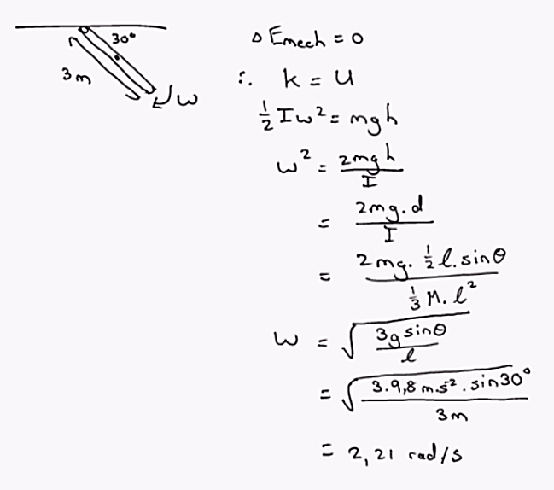

Chapter 16: Wave Motion
- Model that transfers energy through space without material being moved
- Types:
  - Mechanical (sound/water)
  - Electromagnetic (radio/light)

Propagation of waves
- For mechanical waves – a disturbance in the medium is required
- Transverse waves – a point on the wave moves perpendicular to the motion of the pulse
  - E.g. using a rope as a medium, moving it up and down and the wave moves forward
  - Each part of the rope only moves up and down
- Longitudinal waves – a point in the wave moves parallel to the motion of the pulse
  - E.g. sound waves
- Some waves can be a combination of both longitudinal and transverse
- For a single pulse:
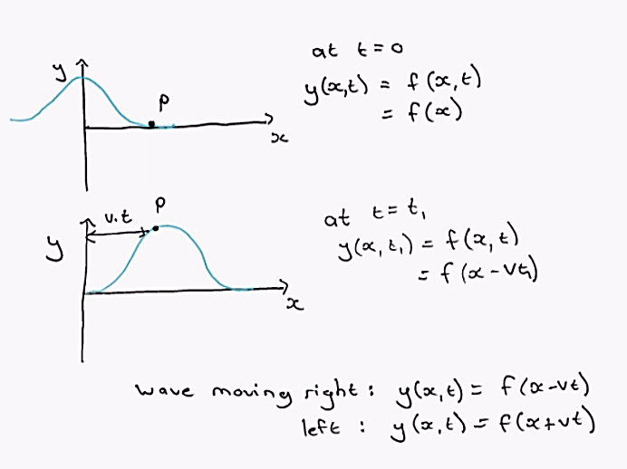

Moving Waves
- Describing a specific function for waves moving through an infinite medium – sinusoidal waves
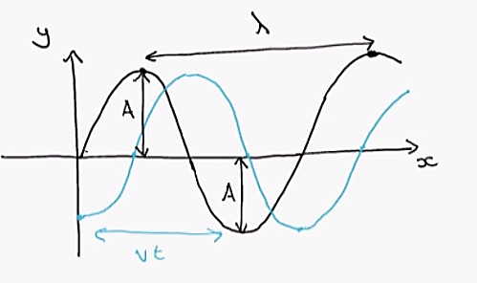
- λ – wavelength
- A – amplitude
- Vt – the change in displacement in terms of time

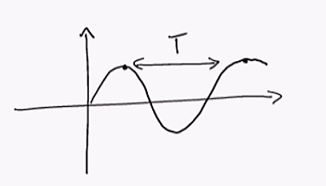
- T – the period of the function – time taken for a single wavelength to pass one point
- f – frequency – the rate at which wavelengths pass a point (hertz)
            - $f=\frac{1}{T}$

- Developing equations showing the function of these waves
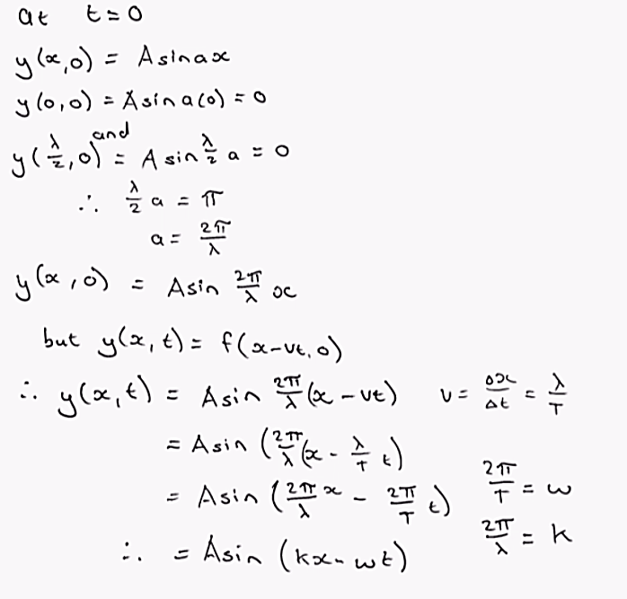
  - $y\left(x,t\right)=Asin\left(kx-ωt\right)$
  - $v=\frac{ω}{k}=λf$
  - Can also add a phase constant - $y\left(x,t\right)=Asin\left(kx-ωt+φ\right)$
Example: A sinusoidal wave with amplitude 1.0 cm and a frequency of 100 Hz moves at 200 m/s in the positive x direction. At t=0, the point x = 1.0m is at the crest of the wave.
- Determine values for A, v, f, T, λ, k and ω for the wave
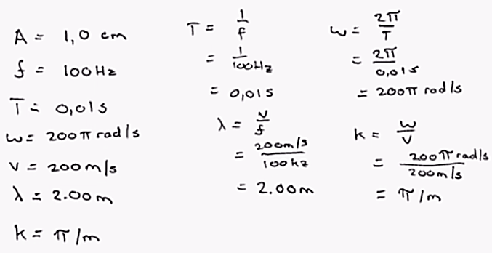
- Find φ
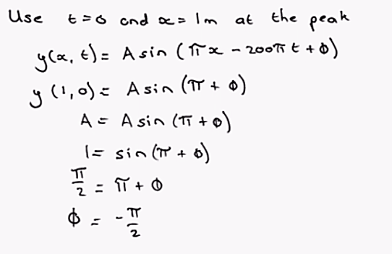
- Transverse speed and acceleration
  - $v_{y}=-ωAcos\left(kx-ωt\right)$
  - $a_{y}=-ω^{2}Asin\left(kx-ωt\right)$
  - $v_{max}=ωA$
  - $a_{max}=ω^{2}A$

Chapter 17: Superposition and Standing Waves

Superposition and interference
- If two or more travelling waves moving through a medium overlap then the resulting wave is the sum of the individual waves
- If two waves are perfectly in phase – constructive interference
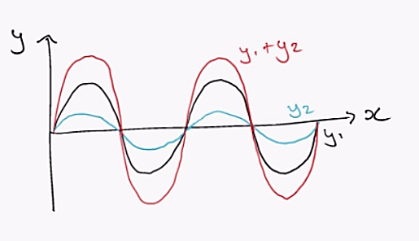
- If two waves are perfectly out of phase – destructive interference
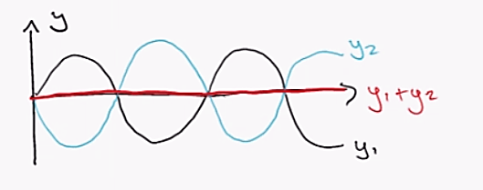

- Superposition of sinusoidal waves
  - For two waves traveling in the positive, x direction, with the same frequency, wavelength and amplitude:
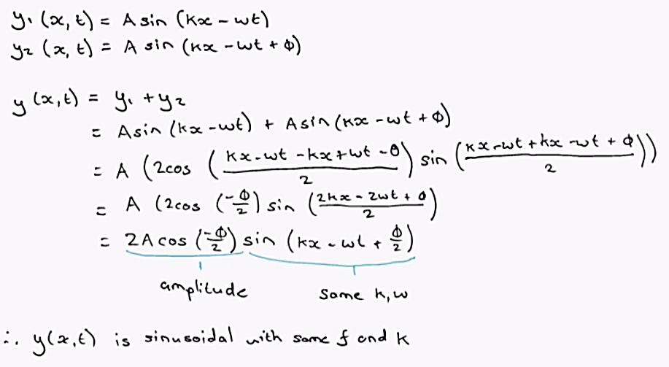
- If φ = 0 then amplitude is 2A
  - Thus waves are perfectly in phase
  - Thus φ can be a multiple of 2π for waves to be in phase
- If φ is an odd multiple of π (3π, 5π…)
  - Then waves are perfectly out of phase
  - Amplitude = 0
  - Destructive interference occurs
- For all other values, the amplitude lies between 0 and 2A

Standing waves
- If two waves travel in opposite directions with the same frequency, wavelength and amplitude
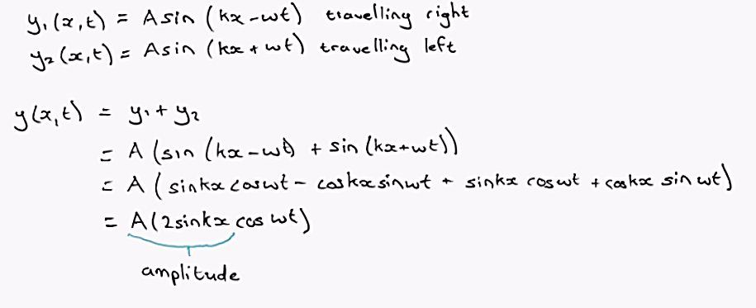
- No longer a relationship between kx ∓ ωt – wave is now standing
  - Equation is a special kind of SHM – every molecule oscillates in this pattern
- Amplitude depends on the x-value via $sin(kx)$
  - Value of zero if $sin(kx) = 0$
  - Thus $kx = 0, π, 2π…$
  - But $k=\frac{2π}{λ}$
    - $∴x=0,\frac{λ}{2}, λ…$
  - These points are called nodes
- Greatest displacement is at y = 2A
  - If $\sin\left(kx\right)=±1$
  - $kx=\frac{π}{2},\frac{3π}{2}…$
  - $x=\frac{λ}{4},\frac{3λ}{4},\frac{5λ}{4}…$
  - These points are called antinodes
Example: Two waves travel in opposite directions in the same medium with the same period, 32,2s the same wavelength, 6,23m and the same amplitude, 3,45m. What is the wave function of the resulting wave if the waves overlap in space?
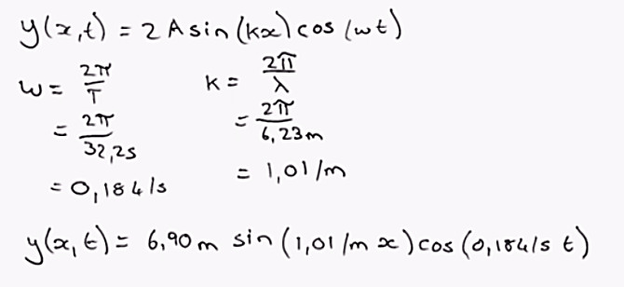
Example: A standing transverse wave on a string of length 60cm is represented by:
$$y\left(x,t\right)=4,0cm\sin\left(\frac{π}{15}x\right)\cos\left(96πt\right)$$
- What is the maximum value of the standing wave at x = 5.0cm
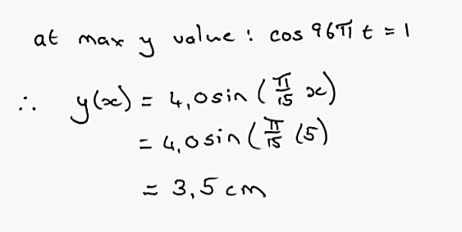

- Where are the nodes located?
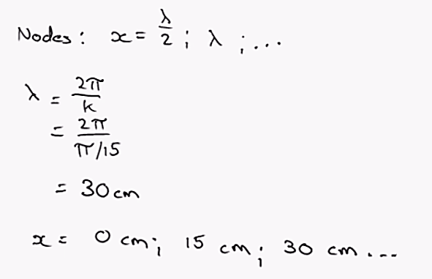
- What is the vertical velocity of the string at x = 7,5cm , t = 0,25s
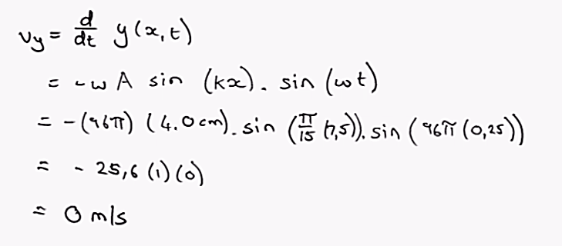

Chapter 19: Temperature
- Thermal contact – position where heat can be transferred between objects
- Temperature – the ability of an object to transfer heat through thermal contact
  - Is a state of vibration of the objects atoms

Thermometers and the Celsius Scale
- Physical Properties that change with temperature
  - Volume of liquid
  - Dimensions of a solid
  - Pressure of gas at a constant volume
  - Volume of gas at a constant pressure
  - Electric resistance
  - Colour of an object
- Thermometer – mercury
  - Uses the expansion of mercury as temperature increases
  - Temperature change becomes proportional to the change in length of the liquid column
- Celsius scale
  - Uses the freezing point of water as zero
  - Uses the boiling point at sea level as 100
- Kelvin Scale
  - Uses absolute zero (-273.15°C) as zero
  - Uses the same increment scale as Celsius

Thermal Expansion of Solids and Liquids
- Each material expands or shrinks at a different rate
  - Linear expansion - $α=\frac{∆L}{L_{i}∆T}$
    - $∆L={αL}_{i}∆T$
  - Volumetric expansion - $∆V={βV}_{i}∆T$
- Finding the relationship between α and β
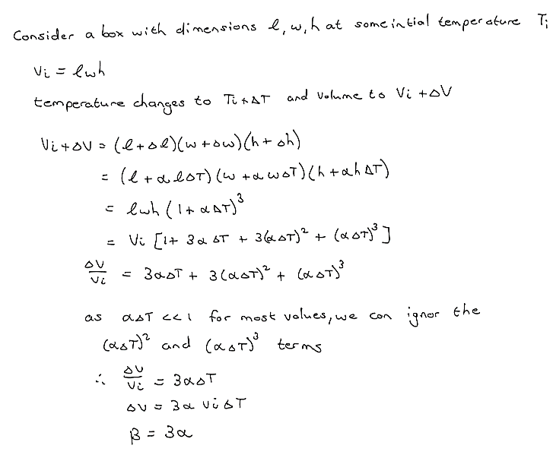
Example: A copper wire has essentially no sag between poles 35m apart on a winter day when the temperature is -20°C. How much longer is the wire on a summer day when the temperature is 35°C?
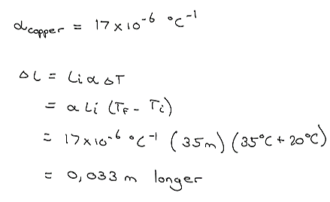

Macroscopic Description of an Ideal Gas
- As gas doesn’t have a set volume, the volume equation does not apply
- Ideal gas – gas that is maintained at a low pressure
- If an ideal gas is confined to a container with a movable piston
  - If the gas is kept at a constant temperature – volume is inversely proportional to pressure
  - Pressure contestant – temperature proportional to volume
  - Volume constant – pressure proportional to temperature
- $PV=nRT$
  - R = 8.314J/mol.K - the universal gas constant
  - N – number of moles of gas
- If using number of molecules instead of moles
  - $PV=NkT$
    - K – Boltzmann’s constant – R/N_{a}
Example: An automobile tire is inflated with air originally at 10.0°C and at normal atmospheric pressure. During the process, the air is compressed to 28% of its original volume and the temperature is increased to 40°C. What is the tire pressure?
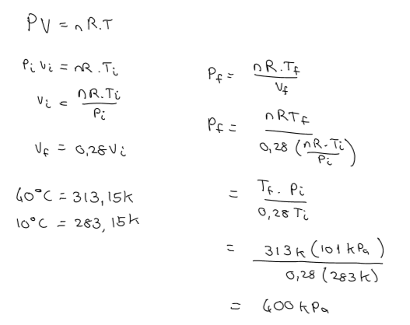

Chapter 20: First Law of Thermodynamics

Heat and Internal Energy
- Internal energy – the energy of a system that is associated with is microscopic components
- Heat (Q) – process of transferring energy across the boundary of a system because of a temperature difference between the system and its surroundings

Specific heat and Calorimetry
- Heat capacity (C) – the amount of energy needed to raise a sample of substance by 1°C
  - $Q=C∆T$
    - Q – the heat entering the system
  - Specific heat (c) – the amount of energy required per unit mass
    - $Q=cm∆T$
- Thus $mc∆T$ – the change in chemical energy
- If given two substances in thermal contact with one another, not in thermal equilibrium
  - $Q_{hot}=-Q_{cold}$
  - $m_{x}c_{x}\left(T_{f}-T_{x}\right)=-m_{y}c_{y}\left(T_{f}-T_{y}\right)$
Example: A combination of 0.250kg of water at 20.0°C, 0.400kg of aluminium at 26°C and 0.100kg of copper at 100°C is mixed in an insulated container and allowed to come to thermal equilibrium. What is the final temperature of the mixture?
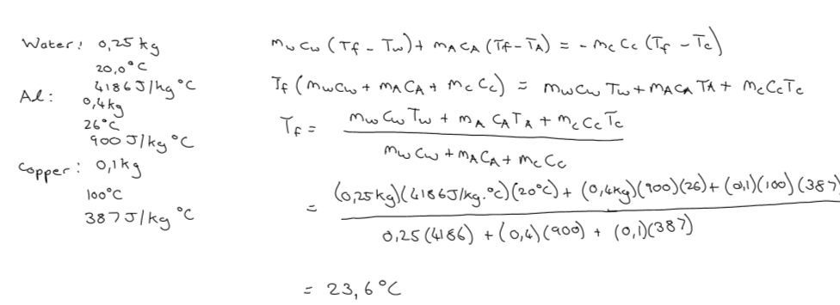

Latent Heat
- As phase changes occur, heat is added to a substance increasing the internal energy but not the temperature
  - The internal energy is in the form of bond energy
  - Thus latent heat is the heat change as a result of phase change
- $L=\frac{Q}{∆m}$
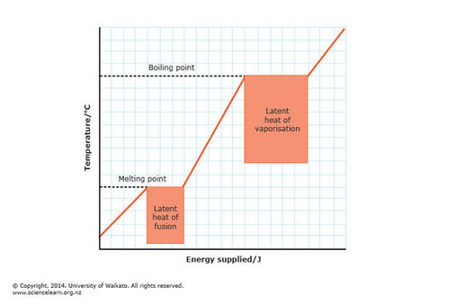
  - Δm – the change in mass of the higher phase material
  - Latent heat values are given most often

Example: A 75kg cross country skier glides over snow. The co-efficient of friction between the skis and snow is 0.200. Assume all the snow beneath the skis is at 0°C and that all the internal energy generated by friction is added to snow which sticks to his skis until it melts. How far would he have to ski to melt 1kg of snow?
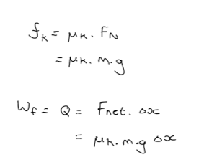
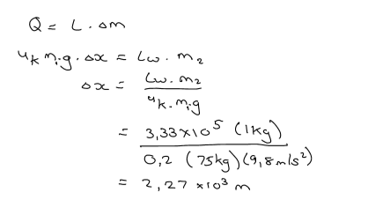

Work and Heat in Thermodynamic Processes
System can described as a group of variables
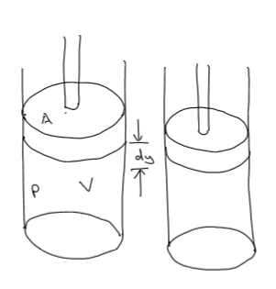
- State variables – system is in thermal equilibrium internally
  - Pressure, volume, temperature and internal energy
- Transfer variables – variable that indicate transfer of energy across the system boundary
  - Heat and work
- When considering a cylinder with a movable piston]
  - $dW=-PdV$
  - Thus if volume decreases, positive work is done
  - $W=-\int_{V_{i}}^{-V_{f}}{P}dV$
  - Have to have Pressure as a function of volume change
- Cyclic process
  - If the piston moves up and down in one motion back to its original position
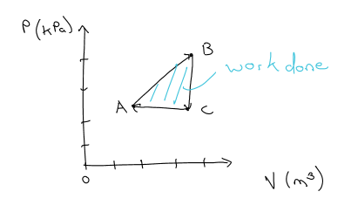
  - The graph will look like a shape – area in the middle is the work

The first Law of Thermodynamics
- Special Law of conservation of energy
  - $∆E_{int}=Q+W$
- If using a cyclic process as seen above (graph) - $∆E_{int}=0$
  - Q = - W
- This law is only applies to a closed system – no matter enters or leaves
Example: A gas is taken through a cyclic process described below. (a) Find the net energy transferred to the system by heat during one complete cycle. (b) What is the system is reversed?
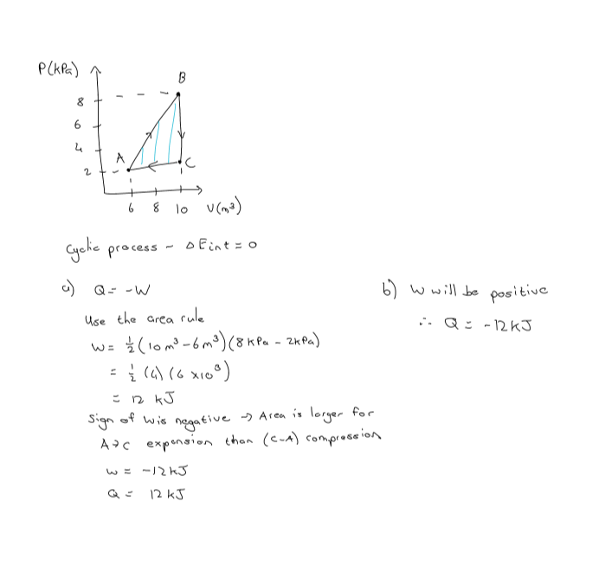

Applications of the First Law
- Adiabatic processes
  - No heat enters or leaves the system
  - $E_{int}=W$
  - Gas does not exert a force of the piston – fills a vacuum
  - Thus the gas does no work
- Isobaric process
  - Pressure is kept constant
  - $W=-P\left(V_{f}-V_{i}\right)$
- Isovolumetric process
  - Volume is kept constant
  - Thus W = 0
  - $E_{int}=Q$
- Isothermal Process
  - Temperature is kept constant
  - ${∆E}_{int}=0$
  - $Q=-W$
Example: In figure below, the change in internal energy of a gas that is taken from A to C along the blue path is +800J. The work done on the gas along the red path ABC is -500J.
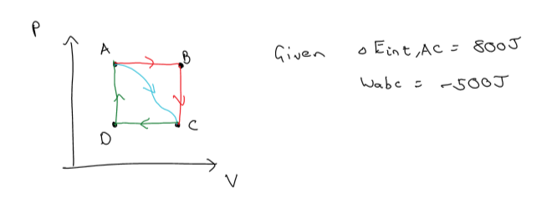
- How much energy must be added to the system by heat as it goes from A through B to C?
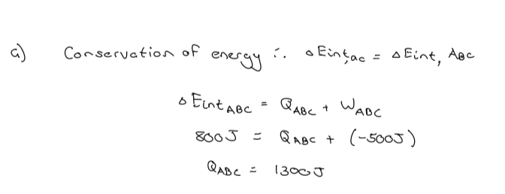

- If the pressure at point A is five times that of point C, what is the work done on the system going from C to D?
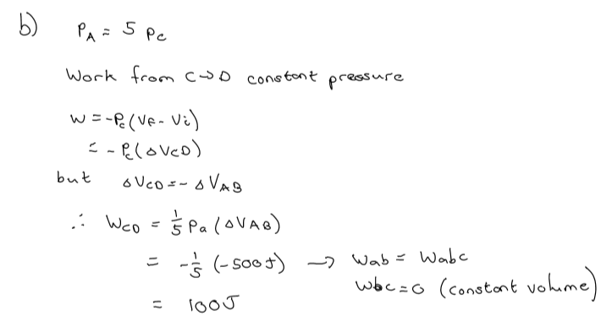
- What is the energy exchanged by the surroundings by heat as the gas goes from C to A along the green path?
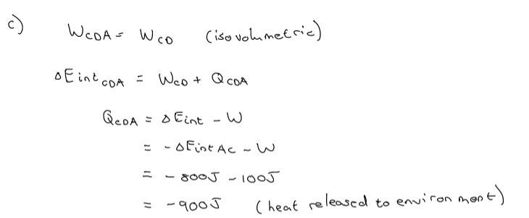
- If the change in internal energy in going from point D to point A is +500J, how much energy must be added to the system as it goes from point C to point D?
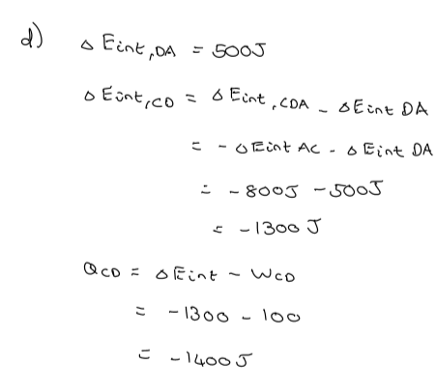
- Isothermal expansion of an ideal gas
  - Ideal gas, thus PV = nRT is a constant
  - Using work integration equation $W=nRTln\left(\frac{v_{i}}{v_{f}}\right)$
Example: An ideal gas undergoes a process in which its pressure is doubled from P_{i} = P₀ to P_{f} = 2P₂ while the volume doubles from V_{i} = V₀ to V_{f} = 2V₀. The pressure increases linearly with the volume. How much heat does the gas exchange with its environment during the process? Given that $E_{int}=\frac{3}{2}nR∆T$ for an ideal gas.
